**Developing *in vitro* models to assess fish gill excretion of emerging contaminants**

**Elisabeth Dohmann Chang1, Stewart F. Owen2, Christer Hogstrand1#, Nic R. Bury1,3,4,**

1. King’s College London, Division of Diabetes and Nutritional Sciences, Franklin Wilkins Building, 150 Stamford Street, London, SE1 9NH, United Kingdom

2. AstraZeneca, Global Sustainability, Alderley Park, Macclesfield, Cheshire SK10 4TF, United Kingdom.

3. University of Suffolk, School of Engineering, Arts, Science and Technology, James Hehir Building, University Quays, Ipswich, Suffolk, IP3 0AQ, United Kingdom, and Suffolk Sustainability Institute.

4.Suffolk Sustainability, University of Suffolk, Waterfront Building, Neptune Quay, Ipswich, IP4 1QJUK.

# - corresponding author

Email: christer.hogstrand@kcl.ac.uk

**Graphic Abstract**

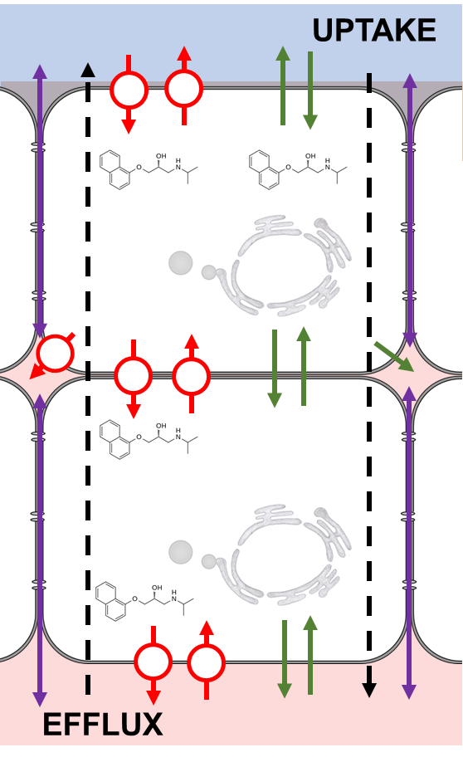

**Abstract**

Advances in analytical methods have enabled the detection of emerging contaminants at ever lower concentrations in freshwaters. However, such measurements need to be linked to effect-based assays to identify risks. The bioconcentration factor (BCF) forms part of a chemical’s environmental risk assessment (ERA), and current regulatory testing guidelines to calculate fish BCFs use hundreds of fish per chemical. Due to ethical concerns a reduction in the numbers of animals used is desired, and there is a need to identify *in vitro* or *in silico* alternatives which meet regulatory acceptance. This study describes the successful demonstration of a FIsh Gill Cell culture System (FIGCS) to assess an often overlooked parameter in pharmacokinetics: the excretion of drugs across the gill. The FIGCS tolerates the application of natural waters on its apical surface, mimicking the situation of the live fish, and thus in combination with advanced analytical methods, offers an opportunity to take lab-based testing used for ERA, such as compound uptake, biotransformation or excretion directly into field for validation with natural waters. Here we used the basic drug propranolol and the acidic ibuprofen as a demonstration of the FIGCS utility in three separate experiments. Excretion across the apical membrane showed saturation kinetics, suggesting the involvement of carrier-mediated processes. Both propranolol and ibuprofen were excreted across the epithelium from the media (internal blood equivalent) to the water, with ibuprofen excretion being considerably slower than propranolol. Further studies indicate that ibuprofen may be complexing with foetal bovine serum (FBS) reducing bioavailability; in contrast propranolol was unaffected, indicating that drugs behave differently in the presence of FBS and other plasma proteins. A key issue in future ERA is to better understand the effects of mixtures of different pollutant classes found in environmental samples, and this model offers an ethical path to do this.

**Introduction**

Advances in analytical chemistry have enabled detection of emerging contaminants at ever lower concentrations. Targeted approaches enable the measurement of hundreds of organic compounds in a sample 1,2 rapidly - within minutes 3- and non-targeted and suspect screening approaches have the capacity to identify many more compounds 2,4. Being able to measure compounds in the external media (e.g., freshwater) does not necessarily equate to an effect in an organism and thus these analytical measurements need to be linked to effect-based assays to identify any potential risks more reliably. Environmental risk assessment (ERA) thus involves *in* *vivo* acute and chronic toxicity testing to identify a chemical concentration which causes an effect, as well as measured or predicted chemical concentration in the environment. It is not possible to generate data for all species and a correction/safety factor is applied to generate a hazard concentration which aims to protect biota. When the environmental concentration exceeds this hazard quotient a risk is identified. However, it is well established that it is the concentration of the compound in the organism that will determine an effect. Recent advances in extraction methods have enabled whole body residues to be determined 5 and matrix-assisted laser desorption/ionization (MALDI), coupled with time-of-flight or Fourier transform ion cyclotron resonance mass spectrometry, allows for the localisation of pharmaceutical in tissues 6. This information can help to determine threshold of effects 5,7.

For chemicals which are not otherwise exempt, and are manufactured in excess of ten tonnes per year, the assessment of bioaccumulation forms part of a regulatory chemical’s risk assessment and the OECD 305 (Bioaccumulation in Fish: Aqueous and Dietary Exposure) test 8 is one guideline which has regulatory approval to determine a chemical’s bioconcentration factor (BCF). The BCF is a dynamic measure based on the ratio of uptake and depuration and differs from other measures such as bioaccumulation factor (BAF), which measures the ratio of the water and biota concentration and tends to be more used in the academic literature. A bioaccumulation study is triggered if the log octanol – water partition coefficient is greater than 4.5. If the chemical BCF exceeds 2000 L/kg, then it is classified as bioaccumulative (B), or, where in excess of 5,000 L/kg, is classified as very bioaccumulative (vB). Within an organism the BCF is dependent on the rate of adsorption and excretion. To understand and predict effect adsorption, distribution, metabolism, and excretion (ADME) need to be understood. These physiological processes are referred to as pharmacokinetic and pharmacodynamics in drug development.

The OECD 305 test guidelines use hundreds of fish per compound, take weeks to complete and are expensive. There are also ethical concerns over the use of so many fish 9. The 3Rs principle refers to the desire to refine, reduce and replace animals in toxicity tests and research 10. These principles are concerned with the ethics of animal testing and balance the societal concerns over the use of animals and the need to ensure chemicals can be handled and used safely 11. Many regulatory bodies have incorporated the 3Rs principles into their policies, including EU Registration, Evaluation, Authorisation and restriction of new CHemicals (REACH) legislation, which states that animal testing should be a last resort and alternative approaches should be used when possible 12. Indeed, for the BCF study there is the possibility to conduct the study at just one concentration in some circumstances and significantly reduce the number of fish needed 13. These alternative methods must adhere to the “Solna” principles and for regulatory purposes must be biologically relevant, reproducible and have regulatory acceptability 11. Popular *in silico* alternative approaches include quantitative structure–activity relationship models (QSARs), biomimetic and surrogate models 13. Many of these are based on read-across/analogue strategies which use chemical categorization and grouping approaches to assess the relevance of information on known chemicals to non-tested chemicals 13. QSARs have been extensively used to predict BCF values, mainly based on correlations with the n-octanol-water partition coefficient Kow 13. Regression based BCF models are derived by statistical analysis of physiochemical properties and available data. Mechanistic BCF models include or directly estimate rate constants for key uptake and elimination processes 14, and require biological characteristics and environmental conditions for input 15.

Several *in vitro* methods exist as alternatives to whole fish studies including a multitude of fish cell lines and primary cell culture methods 16. One such system is the FIsh Gill Cell culture System (FIGCS) which uses a double seeding technique onto inserts to develop a 3-compartment model, the apical and basolateral compartment and the double cell layer 17,18. The epithelium forms exceptionally tight junctions 19 and tolerates the application of water to the apical surface 18. The advantage of using an *in vitro* model for the fish gill is the reduction in the number of fish used; FIGCS typically produces 24 – 48 inserts from 2 donor fish. This system has been used to assess the uptake of ionizable pharmaceuticals 19-21, the adsorption process in ADME.

As part of any ADME assessment, excretion of the compound or its metabolites is a key factor determining the bioaccumulation properties of compounds and details of this process is required to develop models to predict BCFs. In fish the main site of xenobiotic excretion is via the liver22, but a seldom overlooked potential site of efflux may occur across the gills 23. The gills are known to contain biotransformation enzymes e.g. 24,25, as well as P-glycoproteins 26,27, ATP- binding cassette (ABC) 28 and Solute carrier (Slc) 29 transport proteins known to transport organic compounds or their metabolites. Thus, the gill has been shown to excrete metabolised hydrophobic chemicals 23, as well as neonicotinoids 30, albeit at a slower rate than the liver. We have also observed efflux of several drugs (propranolol, metoprolol, formoterol, terbutaline, ranitidine and imipramine) across FIGCs, suggesting an excretory pathway; however, excretion was not a focus of this study.

The current study used the FIGCs model to assess the excretion of the basic propranolol and acidic ibuprofen from the gills. Three studies were conducted: (1) the epithelial cells were exposed to Artificial Freshwater (AFW) at different pH (pH 5 – 9) containing propranolol - after the cells have been loaded, the radiolabelled AFW and media were replaced, and the efflux across the apical and basolateral membrane was monitored; (2) propranolol and ibuprofen were placed in the basolateral media and the efflux into the apical compartment was monitored, and (3) as the efflux of ibuprofen was considerably less than propranolol, efflux of the two drugs in the presence or absence of foetal bovine serum (FBS) was assessed. The study utilised radiolabelled compounds for this proof of concept study, but there is great potential to use this system to assess multi-compound uptake or excretion utilising advanced analytical techniques and extraction processes e.g. 31,32. As the FIGCS system has been demonstrated to tolerate and respond to natural waters containing pollutants 33.34, there is scope to study uptake, biotransformation and excretion in fish gills exposed to chemicals in complex aquatic matrices.

**Results and Discussion**

Chang et al 21 demonstrated that external water pH influences the intracellular accumulation of the basic drug propranolol, as well as showing that the drugs transfer across the FIGCs epithelium. Thus, the rationale for exposing the cells for 12 hours at pH 5, 6, 7, 8 or 9 and radiolabelled propranolol was to generate a range of intracellular concentrations (Figure 1A). Propranolol has a p*K*a of 9.42 dm3 mol-1 35-38, and as the external water pH rises, the unionised fraction increases. Previous studies have identified that the unionised fraction of ionizable compounds are more readily available 39-45, including ionizable pharmaceuticals 19,21,46-48. The intracellular pH of the FIGCs is 7.43 49 the deprotonation and protonation of the drug is rapid resulting in the cytosolic propranolol being >99% ionised. This would maintain an external concentration gradient for the unionised fraction and in part can explain the larger mass of unionised compound moving across the apical epithelium at the higher pH values (Figure 1 A). However, the uptake process involved in membrane transfer is currently unclear. In the study of Chang et al 21 the acidic drug ibuprofen uptake rate plateaued as the unionised fraction also increased and a similar trend was seen with propranolol, results suggesting a saturation of the transport process characteristic of carrier mediated transport.

Once accumulated in the cytosol excretion occurred across both the apical and basolateral membranes, with most of the accumulated propranolol being excreted from the cells across both membranes over the first 4 h (Figure 1A). In all compartments, apical AFW (pH 7.4), intracellular cytosol (pH 7.43) and the basolateral media (pH 7.7), the fraction of unionised drug is high - 0.9, 1 and 1.9%, respectively. At the end of the efflux experiment, the intracellular radiolabel remaining was not measured, but given the excretion rate and the plateauing of the accumulation in both compartments, it can be assumed that almost all of the propranolol has been excreted. Thus, at some point the concentration gradient of either the ionised or unionised fraction from the cells, to either the apical or basolateral media, would have reversed. This would result in excretion against a concentration gradient and would support the hypothesis that this is via a carrier mediated process. Carrier mediated and active transport processes show saturation kinetics as the concentration of the substrate increases, but isolated enzymes or transport proteins are normally required to assess substrate specificity. The current study system, FIGCS, is a complex of various transport or channel proteins embedded in the epithelial membrane. This represents the influx and efflux properties of the animal, but it less suited for precise characterisation of specific transport processes. However, the propranolol loading protocol produced a range of different intracellular concentrations (Figure 1B) and the rate of initial efflux rate over the first hour could be assessed. The transport across the apical and basolateral membrane was dose-dependent with linear kinetics across the basolateral membrane and saturation kinetics across the apical membrane (Figure 1C). There is a caveat: the intracellular concentration will decrease over the hour as more drug is excreted, making the derivation of transport kinetics difficult. A number of putative solute carrier (SLC) drug transport proteins have been identified 50, including a number in fish 29, 51,52. In addition, transcripts of transporters which transport xenobiotics and their metabolites across polarised epithelium have been identified in trout fish gills 53,54 , including the rainbow trout gill cell line 55. However, Kopf et al 54 reported a large decrease in the transcript of *abcb5* in single seeded primary gill cultures over time (2, 7 and 12 days); despite this the primary cell cultures accumulating the ABC transporter substrates calcein-AM and rhodamine-123, and we see rapid excretion of propranolol in cells that have been in culture for over 7 days. In addition, chemicals (amantadine, cimetidine, cyclosporine A, MK571, quinidine and verapamil) that have previously been used to block some of these transport process have been shown to effect propranolol uptake in FIGCS 19. However, the role of passive and facilitated transport mediated drug uptake processes across biological membranes is debated 56. For example, Zheng et al 57 identified that passive diffusion can account for passage of propranolol across mammalian cell lines. In contrast other mammalian in vitro studies indicated that both propranolol and ibuprofen are substrates for putative drug transporters 56, 58. A combination of passive and facilitated uptake processes have been reported for salicylic acid transport across Caco-2 cells 59, and in a previous study we concluded that propranolol uptake in FIGCS was likely due to both process depending on the concentration of the drug 19.

Propranolol was transported from the basolateral compartment across the FIGCS epithelium into the apical compartment (Figure 2A & B). The external AFW pH influenced this efflux rate, being significantly slower at pH 9 (Figure 2 A inset). In contrast the intracellular concentration increased with increasing pH (Figure 2C). In this instance the intracellular concentration does not reflect the transport rate, which is the opposite of what was observed in the cell loading experiment (Figure 1), where the external AFW was maintained at pH 7.4. The difference between the conditions is the pH gradient across the membrane and thus the speciation of the drug. At pH 9 propranolol is 28% unionised, thus the gradient of the unionised fraction between intracellular and extracellular increases, with the potential of creating a concentration gradient that favours re-uptake from the water into the cells. Thus, in this dynamic system a potential explanation is that the increased in unionised drug on the apical surface may result in greater influx 21, accounting for the increase in intracellular concentrations and a decrease on the apparent flux rate over 24 h.

The efflux rate of ibuprofen was considerably less, with only a small fraction (~1%) appearing in the apical compartment (Figure 3A & B). There was also very little ibuprofen retained, less than 0.1% of that added to the basolateral compartment in the cells after 24 h (Figure 3C), and a similar observation of very little intracellular accumulation of ibuprofen in gill cells was made previously 21. However, of the small amount of ibuprofen excreted across the epithelium, the pH of the receiving water did affect the rate with a greater flux rate being observed in apical water >pH7 (Figure 3A inset). The p*K*a for ibuprofen is 4.59 dm-3 mol-1 35, 36, 56,57 and thus at pH 5 and 6, the fraction of unionised drug increases. We thus have a similar scenario to that for propranolol at pH9, and again a potential explanation is that the increase in external unionised drug concentration suggests more is taken up by the cells 21.

To investigate the reason why the efflux rate of ibuprofen was so low, we performed an efflux experiments in the L-15 with FBS (L15/FBS) and L15-ex media, a simplified media which contains salts, galactose and pyruvate mimicking the ion concentrations reported for L15 media, but lacking the amino acids and FBS. Ibuprofen efflux rate was significantly enhanced in L-15 ex media compared to L15/FBS (Figure 4 A). In contrast there was no effect on propranolol efflux between the two media. There was also a significant increase in the intracellular concentration of ibuprofen in L15-ex media (5.43 ± 0.65 pmole cm-2) compared to L15/FBS (0.87 ± 0.23 pmole cm-2), and also a smaller but significant increase in propranolol treatment (L15-ex 0.45 ± 0.003 pmole cm-2; L15/FBS 0.32 ± 0.05 pmole cm-2), (Figure 4B). The reason for the much slower efflux rate of ibuprofen and lower intracellular propranolol may be due to adsorption to FBS reducing bioavailability. Henneberger et al 31 have recently shown that FBS in PBS binds to ibuprofen, as well as other acidic drugs such as diclofenac and naproxen, and reduces the interaction with cell components affecting the concentration effect relationship of *in vitro* bioassays. In addition, propranolol has been shown to bind to plasma proteins 58. The observation that the bioavailability of two drugs are affected by FBS has implications for cell-based assays assessing bioaccumulation, biotransformation and cytotoxicity, and stresses the importance of measuring the free concentration of the chemical in solution 31. This may also apply to the pharmacokinetic and pharmacodynamic properties of a drug in fish where plasma-binding protein kinetics may vary between drug but are seldom measured. For example, in the case of ibuprofen, individual plasma concentration varied considerably in fathead minnow exposed to the drug from the water and this may in part be due to inter-individual variation in plasma protein profiles and concentrations 59.

There are other potential explanations for the increased efflux of ibuprofen in L15/ex media. The amino acids are substrates for a number of transport proteins which are putative drug transporters 50, such as members of the SLC families 60,61. Transfer of ibuprofen across the basolateral membrane into the cell is via one of these transport processes, and the amino acids may compete with uptake. In addition, ibuprofen has been found to reduce the gene expression of a number of ABC transport in TOV -21 G cells , a human ovarian adenocarcinoma cell line 67, and thus may reduce the number of facilitated transport proteins capable of removing the drug from the cells. Further work is required to identify and characterise gill drug transport substrates and the influence of drugs on the expression of these transport proteins.

**Conclusion**

The current study demonstrates that a model of the fish gill can be used to assess excretion of compounds across this epithelium, as well as from the cell into the water or into the body. These complements uptake studies using FIGCS which show the transfer of drugs from the water across the epithelium 19-21. This excretion study would be extremely difficult to do with whole fish, thus demonstrating the utility of this system to generate branchial efflux data which can feed into future refined models to predict emerging chemical BCFs. However, a limitation of this study is the use of hazardous radiolabels, although when this system is combined with advanced analytical methods that can measure 100s to 1000s of compounds, considerable amounts of data can be generated. An issue in aquatic toxicology and environmental regulations is how to deal with complex mixtures in natural waters. The FIGCS system has been shown to tolerate natural waters containing a plethora of organic and inorganic compounds at low concentrations 18. These exposures induce a response with an increase in expression of the metallothionine gene involved in metal sequestration, and protection against free-radicals, with cyp1a1 and cyp2a27 both involved in phase 1 metabolism of organic compounds, the latter targeting pharmaceuticals 33,34. High throughput 3 analytical methods which use a non-targeted approach will be able to identify the compartmentalisation (water, cell, media) of the parent compound and their metabolites from natural water. This has the potential to take lab-based testing used for ERA directly into field for validation.

**Experimental.**

**Animal husbandry**

Juvenile rainbow trout (50-120 g) were purchased from a trout farm (Hampshire, UK). Fish were acclimatised to recirculating aerated city of London tap water ([Na+] = 0.53 mM, [Ca2+] = 0.92 mM, [Mg2+] = 0.14 mM, [K+] = 0.066 mM and [NH4+] = 0.027 mM) and maintained at 13-14 °C. Photoperiod was maintained at a constant 14 hour light 10 hour dark cycle and fish were fed a daily 1 % (*w*/*w*) ration of fish chow.

**Gill cell culture**

The isolation and culturing of the FIGCs followed the methods described in Schnell et al 18, also see methods video at http://www.burylabs.co.uk/figcs/. Briefly, all equipment, containers and solutions were autoclaved or sterile filtered (0.2 µm, Corning). For each seeding 2 fish were sacrificed following UK Home Office schedule 1 procedures, the gills were dissected out and the gill filaments were subject to cleaning and tryptic digestion (0.05 % Trypsin-EDTA; Invitrogen) (see Schnell et al 18 for more detailed methods). Isolated rainbow trout gill cells were seeded onto cyclopore polyethylene terephthalate membrane (cell , surface area 0.9 cm2, pore size 0.4 µm, Falcon) at a cell density of 1.5 x 106 per insert, in Leibovitz (L-15) medium without phenol (Invitrogen) supplemented with 5% v/v foetal bovine serum (FBS) (Sigma-Aldrich) and antibiotics [(2 % v/v penicillin (5000 units mL-1 and streptomycin (5mg mL-1) (Invitrogen) and 2 % v/v gentamicin (1mg mL-1); (GIBCO)]. After 24 hrs incubation at 18 °C in an air atmosphere cooler incubator the cells were washed twice in phosphate-buffered saline (PBS, pH 7.4) to remove debris and another seeding of primary gill cells was added at a cell density of 1 x 106 per insert, and cultured in supplemented L-15 medium. After further 24 hrs incubation another PBS wash followed, and supplemented L-15 was replaced at a volume of 1.5 mL in the apical chamber of the insert and 2.0 mL in the basolateral chamber. After 96 hrs the gill cell system was cultured using L-15 medium + 5% FBS, but without antibiotics with complete medium changes every 48 hrs. The development of an intact gill epithelium was monitored daily through ‘blank’-corrected measurements of transepithelial electrical resistance (TEER) using a custom-modified epithelial tissue voltohmeter (EVOMX; World Precision Instruments) fitted with chopstick electrodes (STX-2).

**Branchial intracellular efflux of propranolol**

Once the epithelium had reached a TEER > 5 KΩ [a criterion for the presence of a tight epithelium 19] the apical L-15/FBS media was removed and the cells washed twice with PBS. To the apical compartment was added 800 μL artificial freshwater (AFW) prepared according to OECD203 Test Guidelines 62 [2 mM CaCl2; 0.5 mM MgSO4; 0.8 mM NaHCO3, 77.1 μM KCl (total ionic strength ca. 10 mM)] containing the buffers 30 mM 2-(N-Morpholino ethanesulfonic acid) (MES) (MES hydrate BioUltra, Sigma-Aldrich, cat. # 69890-10g) and 10 mM 1,3-Bis[tris(hydroxymethyl) methylamino] propane (BIS-TRIS propane and pH adjusted to 5, 6, 7, 8 and 9 with NaOH or HCl 21. The pH was monitored with a PerpHecT ROSS Micro Combination pH Electrode (Thermo Scientific, cat. # 8220-BNWP) and Corning pH meter 140. The media in the basolateral compartment was replaced with 1mL of fresh L-15/FBS media. To the apical compartment was added 25nM of L-[4-3H]-propranolol (Perkin Elmer Lot. # 2129303) with a specific activity of 688 GBq mmol-1 (37 MBq mL-1) and the cells were incubated for 12 h. At the end of this period the radiolabelled cells were washed with PBS. One set of cells were washed twice with PBS and dried for 15-20 minutes and then incubated with 500μl DMSO for 1 hour. The DMSO was then agitated by pipetting up and down 25 times and radioactivity measured to assess internal concentration. To another set of cells, the radiolabelled AFW and media was replaced with fresh unbuffered AFW (2 mM CaCl2; 0.5 mM MgSO4; 0.8 mM NaHCO3, 77.1 μM KCl, pH 7.4) in the apical compartment and L15/FBS media in the basolateral compartment. The appearance of the propranolol into the AFW and media was assessed at 1, 2, 3, 4, 6, 8, and 12 h, via measuring the radioactivity in 10µl of fluid. Data was collected from 14 – 16 inserted derived from 4 separate biological replicate.

**Branchial epithelium efflux of propranolol and ibuprofen.**

To assess the efflux of propranolol and ibuprofen FIGCS was grown as described and once the desired TEER was reached the media was replaced and on the apical surface with 800 μL buffered AFW adjusted to pH 5, 6, 7, 8, 9 or L15/FBS and in the basolateral compartment 1 mL of fresh L-15/FBS media containing either 12.5 nM of L-[4-3H]-propranolol or 1.5 µM RS-[carboxyl-14C]-ibuprofen (American Radiolabeled Chemicals, Inc., cat. # ARC 1046-50 μCi) with a specific of 2.04 GBq mmol-1 (3.7 MBq mL-1). Radiolabel appearance in the apical and basolateral media was assessed at 1, 2, 3, 4, 6 and 24 h. Intracellular drug concentrations was assessed after 24 h, as described above. These concentrations are not cytotoxic to rainbow trout primary gill cells 20.

**Drug efflux in L-15/FBS and L15-ex media**

To assess the effect of FBS on drug efflux the excretion rate was determined in symmetrical conditions with L15/FBS in both compartments or L15-ex media which comprises of sterile filtered milliQ water containing 6 mM KCl, 1.1 mM MgCl2, 0.8 mM MgSO4, 1.5 mM CaCl2, 1.5 mM Na2HPO4, 0.5 mM KH2PO4, 50 mM galactose and 50 mM Na pyruvate, and no FBS. To the basolateral compartment 12.5 nM of L-[4-3H]-propranolol or 1.5 µM RS-[carboxyl-14C]-ibuprofen was added and appearance of radiolabel in the apical compartment assessed at 24 h. Intracellular drug concentrations was assessed after 24 h, as described above.

**Radiolabel counting**.

For the propranolol and ibuprofen efflux experiments 10 and 20µL aliquots, respectively, were taken at each time point and for the intracellular drug concentrations a 200µl aliquot of DMSO was taken for counting. Radiolabelled samples were added to 6ml Pico Hang-in vials (Perkin Elmer) containing 2mL Ecoscint A scintillation fluid (National Diagnostics) and shaken before counting. A Beckmann Coulter LS6500 Multipurpose Scintillation Counter machine was used to detect radioactivity, set to count for 10 minutes detecting 3H and 14C. Disintegrations per minute (dpm) values were used to convert counts to concentrations, taking into account background radioactivity. To determine the approximate background activity radiolabelled free buffered AFW at pH 5, 6, 7, 8, and 9, L-15/FBS, L15-ex media and DMSO samples were taken and counted and found to be about 10 dpm for 3H and 14C. Concentrations of drugs in the buffered AFW or media were calculated based on specific activity and expressed as pmole mL-1 or as an efflux rate pmol cm-2 h-1, and intracellular concentrations as pmole cm-2.

**Statistics**

All experiments consisted of at least 8 inserts derived from 3 biological replicates, except the L15-ex experiment which is derived from 4 inserts from 2 biological replicates. Intracellular concentrations and comparisons of efflux rates were assessed via a one-way ANOVA followed by a Tukey’s post-hoc test. Differences between L15/FBS and L15-ex efflux rates and intracellular concentration were assessed via a Student’s T-test. *p* < 0.05 was considered significantly different. All statistics was performed in GraphPad Prism V8.4.3.

**Acknowledgements**: This work was conducted under funding awarded to NRB from the Biotechnology and Biological Sciences Research Council (BBSRC) CASE industrial scholarship scheme (Reference BB/M014827/1), and AstraZeneca Global SHE research programme. AstraZeneca is a biopharmaceutical company specializing in the discovery, development, manufacturing and marketing of prescription medicines, including some products reported here. SFO is an employee of AstraZeneca.

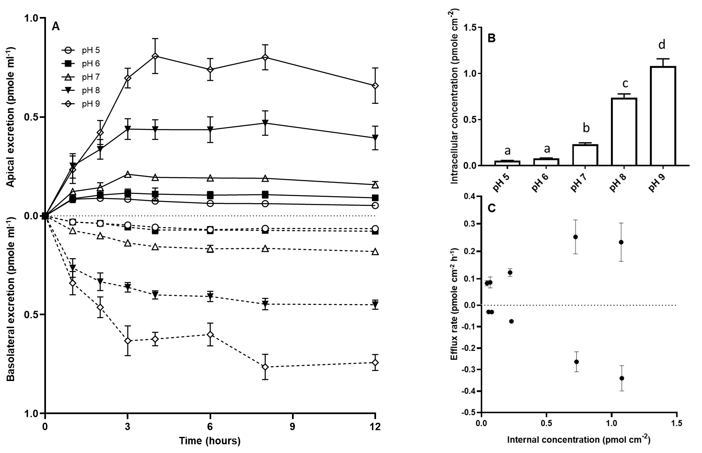

**Figure 1.** (A) Appearance of 3H-propranolol into the apical compartment containing AFW water or the basolateral compartment containing L15/FBS media following the loading of cells (B) with 25nM 3H-propranolol over a 12hr exposure period in buffered AFW water adjusted to pH 5, 6, 7, 8 and 9, to obtain different intracellular propranolol concentrations. In (B) Columns with differing letter above then are significantly different form each other (one-way ANOVA followed by a Tukey’s post hoc test, p<0.05). (C) Efflux rate of propranolol over the first hour expressed as the original internal concentrations. Values represent mean ± SEM from 14 – 16 inserts derived from 4 separate biological replicates.



**A**

**B**



**C**



**Figure 2.** (A) The apical appearance 3H-propranolol of into buffered AFW adjusted to pH 5, 6, 7, 8, 9 or L15 (L15/FBS) media following the addition of 12.5nM 3H-propranolol to the basolateral compartment. Inset the efflux rates based on the concentration of drug int eh apical compartment at 24hrs. Columns with differing letter above then are significantly different form each other (one-way ANOVA followed by a Tukey’s post hoc test, p<0.05) (B) Disappearance of 3H-propranolol from the basolateral compartment. (C) Concentration of 3H-propranolol in the cells after the efflux experiment. In (A) inset and (C) columns with differing letter above then are significantly different form each other (one-way ANOVA followed by a Tukey’s post hoc test, p<0.05). Values represent mean ± SEM from 8 inserts derived from 3 separate biological replicates.



**A**

**C**

**B**



a

a

b

c

c

c

**Figure 3.** (A) The apical appearance 14C-ibuprofen into buffered AFW adjusted to pH 5, 6, 7, 8, 9 or L15 (L15/FBS) media following the addition of 1.5µM 14C-ibuprofen propranolol to the basolateral compartment. Inset the efflux rates based on the concentration of drug in the apical compartment at 24hrs. (B) Disappearance of the 14C-ibuprofen from the basolateral compartment. (C) Concentration of 14C-ibuprofen in the cells after the efflux experiment. Values represent mean ± SEM from 8 inserts derived from 3 separate biological replicates.

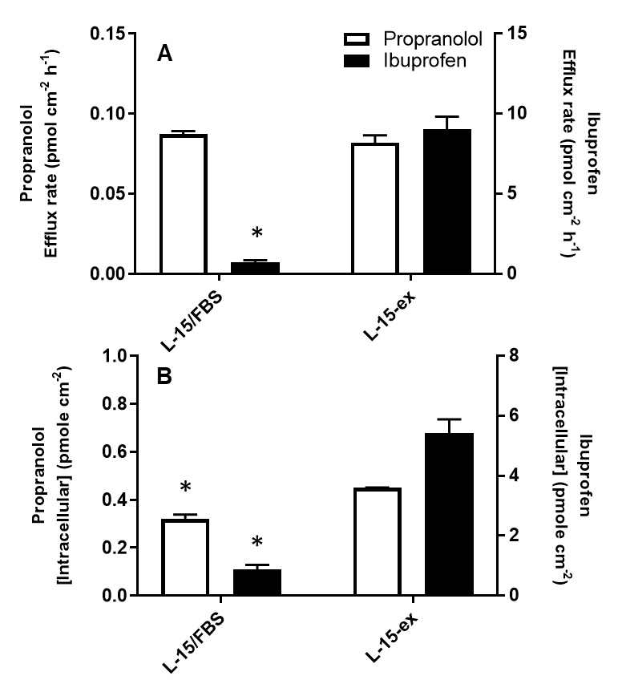

**Figure 4.** (A) The efflux rate and (B) intracellular concentrations of 3H-propranolol and 14C-ibuprofen following application of radiolabelled drug to the basolateral compartment containing L15/FBS or L15-ex. An asterisk indicates significant difference between L15/FBS and L15-ex treatment (Student’s T-Test, p<0.05). For the L15/FBS treatments Values represent mean ± SEM from 8 inserts derived from 3 separate biological replicates and for L15/ex 4 inserts derived from 2 separate biological replicates.

**References**

1. K. Munro K, C.P.B. Martins, M. Loewenthal, S. Comber, D.A. Cowan, L. Pereira, L.P. Barron. *Science of the Total Environment*, 2019, **657**, 1099-1111.
2. A. Ccanccapa-Cartagenaac, Y. Pico, X. Ortiz, E. Reiner. *Science of The Total Environment*, 2019, **687**, 355-368
3. K.T. Ng, H. Rapp-Wright, M. Egli, A. Hartmann, J.C. Steele, J.E. Sosa-Hernández, E.M. Melchor-Martínez, M. Jacobs, B. White, F. Regan, R. Parra-Saldivar, L. Couchman, R.U. Halden, L.P. Barron LP. *Journal of Hazardous Materials*, 2020, **398**,122933.
4. L.P. Barron, G.L. McEneff GL. *Talanta*, 2016, **147**, 261-270.
5. T.H. Miller, K.T. Ng, S.T. Bury, S.E. Bury, N.R. Bury, L.P. Barron. *Environmental International*, 2019, **129**, 595-606.
6. P. Källback, T. Vallianatou, A. Nilsson, R. Shariatgorji, N. Schintu, M. Pereira, F. Barré, H. Wadensten, P. Svenningsson, P.E. Andrén. *Analytical Chemistry*, 2020, **92**, 14676-14684.
7. P.A. Inostroza, A.J. Wicht, T. Huber, C. Nagy, W. Brack, M. Krauss. *Environmental Pollution*, 2016, **214**, 77-85.
8. OECD 305. Bioaccumulation in Fish: Aqueous and Dietary Exposure.
9. L.U. Sneddon, L.G. Halsey, N.R. Bury. *Journal for Experimental Biology*, 2017, **220**, 3007-3016.
10. W.M.S. Russell, R.L. Burch RL. 1959. (as reprinted 1992). The principles of humane experimental technique. Wheathampstead (UK): Universities Federation for Animal Welfare.
11. W. de Wolf, M. Comber, P. Douben, S. Gimeno, M. Holt, M. Léonard, A. Lilicrap, D. Sijm, R. van Egmond, A. Weisbrod, G. Whale G. *Integrated Environmental Assessment and Management*, 2007, **3**, 3-17.
12. S.Scholz, E. Sela, L. Blaha, T. Braunbeck, M. Galay-Burgos, M. García-Franco, J. Guinea, N. Klüver, K. Schirmer, K. Tanneberger, M. Tobor-Kapłon, H. Witters, S. Belanger, E. Benfanati, S. Creton, M.T.D. Cronin, R.I.L. Eggen, M. Embry, D. Ekman, A. Gourmelon, M. Halder, B. Hardy, T. Hartung, B. Hubesch, D. Jungmann, M.A. Lampi, L. Lee, M. Léonard, E. Küster, A. Lilicrap, T. Luckenbach, A.J. Murk, J.M. Navas J.M.; W. Peijnenburg, G. Repetto, E. Salinas, G. Schüürmann, H. Spielmann K.E. Tollefsen, S. Walter-Rohde, G. Whale, J.R. Wheeler, M.J. Winter. *Regulatory Toxicology and Pharmacology*, 2013, **67**, 506-530.
13. N. Burden, S. Creton, L. Weltjec, S.K. Maynard, J.R.Wheeler. *Regulatory Toxicology and Pharmacology*, 2014, **70**, 442-445.
14. T.H. Miller, G.L. McEneff, L.C. Stott, S.F. Owen, N.R. Bury, L.P. Barron. *Science of the Total Environment*, 1026, **547**, 396–404.
15. J.M. Armitage, R.J. Erickson, T. Luckenbach, C.A. Ng, R.S. Proseer, J.A. Arnott, K. Schimer, J.W. Nichols. *Environmental Toxicology Chemistry*, 2017, **36**, 882 -897.
16. N.R. Bury, S. Schnell, C. Hogstrand. *Journal of Experimental Biology*, 2014, **217**, 639-650.
17. M. Fletcher, S.P. Kelly, P. Pärt, M.J. O’Donnell, C.M. Wood. *Journal of Experimental Biology*, 2000, **203**, 1523-1537.
18. S. Schnell, L.C. Stott, C. Hogstrand, C.M. Wood, S.P. Kelly, P. Pärt, S.F. Owen, N.R. Bury. *Nature Protocols*, 2016, **11**, 490-498
19. L.C. Stott, S. Schnell, C. Hogstrand, S.F. Owen, N.R. Bury. *Aquatic Toxicology* 2015, **159**, 127-137.
20. E.D. Chang, C. Hogstrand, T.H. Miller, S.F. Owen, N.R. Bury, N.R. *Environmental Science and Technology*, 2019, **53**, 1576-1584.
21. E.D. Chang, R.M. Town, S.F. Owen, C. Hogstrand, N.R. Bury. *Environmental Science and Technology* 2021
22. D.E. Hinton, H. Segner, T. Braunbeck. 2001 Toxic response to the liver. In Target Organ Toxicity in Marine and Freshwater Teleosts, eds D. Sclenk and W.H. Benson, pp224 – 268. Taylor and Francis
23. P. N. Fitzsimmons, J.D. Fernandez, A.D. Hoffman, B.C. Butterworth, J.W. Nichols *Aquatic Toxicology*, 2001, **55**, 23–34.
24. B.F. Brammell, J.S. McClain, J.T. Oris, D.J. Price, W.J. Birge, A.A. Elskus. *Archives of Environmental Contamination and Toxicology*, 2010, **58**, 772-82.
25. A.E. Bartram, M.J. Winter, D.B. Huggett, P. McCormack, L.A. Constantine, M.J. Hetheridge, T.H. Hutchinson, L.B. Kinter, J.F. Ericson, J.P. Sumpter, S.F. Owen. *Environmental Toxicology and Chemistry*, 2012, **27**, 573-582.
26. M.J. Hemmer, L.A. Courtney, L.S. Ortego. *Journal of Experimental Zoology*, 1995, **272**, 69-77.
27. M.V. Amé, M.V. Baroni, L.N. Galanti, J.L. Bocco, D.A. Wunderlin. *Chemosphere*, 2009, **74**, 1179-1186.
28. C. Kropf, K. Fent, K., S. Fischer, A. Casanova, H. Segner, H. *Journal of Experimental Biology* 2020, **223**, jeb221069.
29. M. Popović, R. Žaja, K. Fent, T. Smital. *Toxicology and Applied Pharmacology*, 2014, **280**,149-158.
30. J.A. Frew, J.T. Brown, P.N. Fitzsimmons, A.D. Hoffman, M. Sadilek, G.E. Grue, J.W. Nichols. *Comparative Biochemistry and Physiology*, 2018, **205C**, 34-42
31. L. Henneberger, M. Muhlenbrink, F.C. Fischer, B. Escher. *Chemical Research in Toxicology*, 2019, **32**, 168 – 178.

1. [T. H. Miller, N.R. Bury, S.F. Owen, L.P. Barron.](https://www.sciencedirect.com/science/article/pii/S0045653517307877?via%3Dihub" \l "!)  *Chemosphere*, 2017, **183**, 389-400
2. M. Minghetti, S. Schnell, M.A. Chadwick, C. Hogstrand, N.R. Bury. *Aquatic Toxicology*, 2014, **54**, 184-192.
3. S. Schnell, K. Bawa-Allah, A. Otitoloju, C. Hogstrand, T.H. Miller, L.P. Barron, N.R. Bury, N.R. *Ecotoxicology and Environmental Safety*, 2015, **120**, 279-285.
4. A. Avdeef, K.J. Box, J.E.A. Comer, C. Hibbert, K.Y. Tam. *Pharmalogical Research* 1998, **5**, 209–215
5. Canadian Drugbank, <https://www.drugbank.ca/>
6. G.M. Pauletti, H. Wunderli-Allenspach. *European Journal of Pharmaceutical Science* 1994, **1**, 273-282.
7. E. Fuguet, M. Reta, C. Gibert, M. Rosés, E. Bosch, C. Ràfols. *Electrophoresis*, 2008, **29**, 2841-2851
8. R.J. Erickson, J.M. McKim, G.J. Lien, A.D. Hoffmann, S.L. Batterman. *Environmental Toxicology and Chemistry*, 2006, *25*, 1512-1521.
9. R.J. Erickson, J.M. McKim, G.J. Lien, A.D. Hoffmann, S.L. Batterman. *Environmental Toxicology and Chemistry*, 2006, *25*, 1522-1532.
10. W. Fu, A. Franco. *Environmental Toxicology and Chemistry*, 2009, **28**, 1372-1379.
11. S. Trapp, A. Franco, D. MacKay. *Environmental Science and Technology,* 2010, **44**, 6123-6129.
12. J.M. Armitage, J.A. Arnott, F. Wania, D. MacKay. *Environmental Toxicology and Chemistry*, 2013, **32**, 1 - 14.
13. J.M. Armitage, R.J. Erickson, T. Luckenbach, C.A. Ng, R.S. Proseer, J.A. Arnott, K. Schimer, J.W. Nichols*. Environmental Toxicology and Chemistry*, 2017, **36**, 882 -897.
14. B.I. Escher, R. Abagyan, M. Embry, N. Klüver, A.D. Redman, C. Zarfl, T.F. Parkerton. *Environmental Toxicology and Chemistry,* 2020, **39**, 269-289.
15. A. Baumer, K. Bittermann, N. Klüver, B.I. Esher B.I. *Environmental Sciences: Processes and Impacts*, 2017, **19**, 885-976.
16. L. Bittner, E. Teixido, B. Seiwert, B.I Escher, N. Klüver. *Aquatic Toxicology*, 2018, **201**, 129-137.
17. D. Alsop, J.Y. Wilson, J.Y. *Aquatic Toxicology,* 2019, **210**, 11-18.
18. P. Pärt, C.M. Wood. Journal of Comparative Physiology, 1996, **166B**, 37-45.
19. D.B. Kell, S.G. Oliver. *Frontiers in Pharmacology*, 2014, **5**, Article 231
20. I. Mihaljević, M. Popović, R. Žaja, N. Maraković, G. Šinko, T. Smital. *Aquatic Toxicology*, 2017, **187**, 18-28.
21. J. Dragojević, I. Mihaljević, M. Popović, T. Smital. *Comparative Biochecmistry and Physology*, 2019, *236B*, 110309
22. J. Loncar, M. Popović, Z. Roko, T. Smital. 2010. Comparative Biochemistry and Physiology 151C, 209-215.
23. C. Kropf, K. Fent, S. Fischer, S.; Casanova, A.; Segner, H. *Journal of Experimental Biology*, 2020, **223**, DOI: 10.1242/jeb.221069
24. S. Fischer, J. Loncar, Z. Roko, S. Schnell, K. Schirmer, T. Smital, T. Luckenbach. *Aquatic Toxicology*, 2011, **101**, 438 – 446.
25. K. Sugano, M. Kansy, P. Artursson, A. Avdeef, S. Bendels, L. Di, G.F. Ecker, B. Faller, H. Fischer, G. Gerebtzoff, H. Lennernaes, F. Senner. *Nature Reviews Drug Discovery*, 2010, **9,** 597–614.
26. Y. Zheng, L.Z. Benet, H. Okochi, X. Chen. *Pharmaceutical Research* 2015, **32**, 2516-2526.
27. M.M. Parvez, N. Kaisar, H.J. Shin, Y.J. Lee, J-G. Shin J-G. *Antimicrobial Agents and Chemotherapy*, 2018, 62, e00512-18.
28. S. Neuhoff, A-L. Ungell, I. Zamora, P. Artusson. *European Journal of Pharmaceutical Sciences*, 205, **25**, 211-220.
29. The IUPAC Stability Constants Database, The IUPAC Stability Constants Database, SC-Database. https://old.iupac.org/publications/scdb/index.html
30. K.Y. Tam, K. Takács-Novák. *Analytical Chimica Acta*, 2001, **434**, 157-167.
31. L. Michalcova, H. Nevidalova, Z. Glats. *Journal of Chromatography A* **1635**, 461734
32. A. Patel, G.H. Panter, H.T. Trollope, Y.C. Glennon, S.F. Owen, J.P. Sumpter, M. Rand-Weaver, M. *Chemosphere*, 2016, **163**, 592 – 600.
33. G. Superti-Furga, D. Lackner, T. Wiedmer, A. Ingles-Prieto, the RESOLUTE consortium and Claire M. Steppan. *Nature Reviews Drug Discovery*, 2020, **19**, 429 -430.
34. E. Girardi, A. César-Razquin, S. Lindinger, K. Papakostas, J. Konecka, J. Hemmerich, S. Kickinger, F. Kartnig, B. Gürtl, K. Klavins, V. Sedlyarov, A. Ingles-Prieto, G. Fiume, A. Koren, C-H, Lardeau, R. Kumaran Kandasamy, S. Kubicek, G. F. Ecker, G. Superti-Furga. *Nature Chemical Biology* 2020, **16**, 469–478.
35. OECD test number 203, Fish, acute toxicity test. <https://doi.org/10.1787/9789264069961-en>
36. R.A. Lima, E. B. Cândido, F.P. de Melo, J.B. Piedade, P.V.T. Vidigal 4, L. M.M. Silva, A. Lopes da Silva Filho. *Revista Brasileira de Ginecologia e Obstetrícia*, 2015, **37**, 283-290.