Can placing lead-rubber inferolateral to the light beam diaphragm limit ionising radiation to multiple radiosensitive organs?

Word Count: 3,402

Abstract

Introduction: This article investigates a practical method of reducing the impact of scattered radiation during a lateral radiographic projection of the elbow. The light beam diaphragm (LBD) is generally accepted to limit ionising radiation using horizontal and longitudinal lead shutters, yet this article evidences further dose limitation by placing lead-rubber inferolateral to the LBD device.

Methods and materials: Using an anthropomorphic phantom and arm construction scattered radiation was recorded at multiple radiosensitive organs. A 15cc ionisation chamber (model 10100 AT TRIAD) was placed on each radiosensitive organ (eye, thyroid, breast, testes, spleen and ovaries) measuring exposure rate (µGy/sec). Dose readings were recorded before and after the placement of lead-rubber inferolateral to the LBD. A paired two sample t-test was undertaken affirming how likely dose limitation was attributable to chance (p < 0.05).

Results: Descriptive and inferential statistics demonstrate dose reduction to radiosensitive organs (right eye 53%, right breast 53%, left eye 39%, thyroid 13%, left ovary 9%, testes 6%, left breast 3% and spleen 2%) upon placement of the lead-rubber inferolateral to the LBD. The paired two sample t-test demonstrated statistically significant dose limitation (t = 2.04, df = 7, p = 0.04) thus significant for radiographic practice.

Conclusion: Placement of lead-rubber inferolateral to the LBD limits dose to multiple radiosensitive organs. Right (53%) and left (39%) eye lens, right breast (53%), thyroid (13%), left ovary (9%), testes (6%), left breast (3%) and spleen (2%) statistically demonstrate dose limiting opportunities to patients.

Introduction

The light beam diaphragm (LBD) is located beneath the X-ray tube housing and contains two sets of shutters enabling a radiographer to permit multiple square and rectangular field sizes.¹ Radiographers are required to keep the ‘field size’ to a minimum by adjusting two sets of shutters (longitudinal and horizontal) placed within the collimator housing. The primary function of the LBD is to limit the primary X-ray beam to an area of clinical interest and reduce unnecessary ionising radiation to patients undergoing radiographic procedures.² Whilst appropriate collimation is generally accepted to limit irradiated tissue, ionising radiation continues to reach other radiosensitive organs outside of the primary beam, a term known as ‘scattered radiation’.^{2, 3} Due to the known hazards associated with ionising radiation, studies continue to offer dose limiting strategies to patients and radiosensitive organs within the general radiographic environment.⁴⁻⁸ The use of lead (Pb) is a common method of dose limitation due to its high atomic number (Z = 82) providing significant photoelectric absorption for energies used within diagnostic radiography and remains depicted in contemporary literature.⁹ This has subsequently led to the manufacturing of lead-rubber devices, such as gonad shields, lead-rubber sheets, lead-aprons and lead-rubber gloves, limiting dose to both operators and patients.⁴

The International Atomic Energies Agency (IAEA)² affirm that shielding (where appropriate) should be used to protect a patient’s radiosensitive organs, typically the breast, gonads, eyes and thyroid. The rationale for ensuring dose limitation is historical, but is maintained by contemporary guidance and evidence-based research.⁴ Currently, legislation within the United Kingdom (UK) asserts that radiographers are expected to keep doses ‘as low as reasonably practicable’ (ALARP) to limit the hazardous affects associated with ionising radiation.¹⁰ This legislative practice derives from the theoretical linear non-threshold (LNT) dose response model proposed by the International Commission on Radiological Protection (ICRP)¹¹ assuming that all ionising radiation has the potential to induce malignant change, hence the rationale to minimise all radiation levels wherever possible.^{10, 11} Methods of dose limitation remain central to a radiographer’s practice and remain evident within the current literature.^{4, 5, 6} Contrary to this, few studies focus on dose limitation using lead-rubber in association with the LBD device. Whilst it is not within the scope of this paper to experiment with all radiography projections, the author(s) decided to select the lateral elbow examination due to the height of the table top (raised to the level of the lower boarder of the axilla and parallel to the image receptor), thus remaining in close proximity to radiosensitive organs identified by the IAEA. It is important to recognise that other radiosensitive organs exist when positioning for either anterior posterior and/or lateral elbow examinations, for example, a patient’s head, neck and thorax remain in close proximity to the table top, yet this paper focuses on dose limitation the breast, gonads (male and female), eyes, thyroid and spleen.
Attempts to understand the induction of stochastic cancers within diagnostic radiography have been debated for decades. Yet, within the current radiobiological paradigm it is generally accepted that a safe radiation exposure (however small), does not exist.¹¹ In response the authors offer an alternate approach to dose limitation by applying lead-rubber inferolateral to the LBD device during a lateral projection of the elbow. It is hypothesised that by placing lead-rubber inferolateral to the LBD device it may limit ionising radiation to multiple radiosensitive organs during a single X-ray exposure. The objectives of this study were to, 1) design a phantom resembling the positioning of a lateral radiographic examination; 2) implement an original method of dose limitation to the side of the LBD device and 3) record exposure rates of scatter ionising radiation to radiosensitive organs and undertake statistical analysis to enhance the reliability and validity of the methodological approach and empirical findings.

Methods and materials

The experiment was undertaken in a controlled X-ray laboratory environment at the investigating academic institution. The list of equipment used during the experiment is detailed below:

- Siemens Multix Pro with Optilix HC100 X-ray tube anode angle 12°
- Polydoros ITS 35 generator
- Female anthropomorphic phantom
- Fuji EC-A cassette and Agfa Curix C1 screens
- Cardinal Health 10100A triad field service kit
- 15cc Ionization chamber model no.96035b and electrometer model no. 35050A.

Anthropomorphic phantom and elbow construction

The X-ray experiment used a female anthropomorphic phantom to simulate a patient and relative radiosensitive organs. The anthropomorphic phantom (Rando Alderson Research Laboratory, Stamford, Connecticut, USA) was designed such that any ionising radiation absorption would mimic an adult patient.¹² The phantom material contains a density of 0.99 g/cm³, an effective atomic number of 7.3.¹² The arm was constructed using real bone(s) to make the elbow joint, consisting of the humerus, radius and ulna (density 1.75 g/cm³). Water (density 1.00 g/cm³) was injected into a saline bag (density 1.11 g/cm³) to simulate human soft tissue. This was used because it contains similar densities associated with human muscle (1.06 g/cm³) and fat (0.91 g/cm³). A plastic mesh (1.15 g/cm³) was created encapsulating the materials, simulating anatomical shape and radiographic positioning of a patient attending for a lateral radiographic examination of the elbow. Whilst this method has been found methodologically useful in previous studies, ^{13, 14} it is important to recognise that the X-ray beam will undergo different absorption and scattering effects on the materials selected for this experiment and thus impacting scattered radiation. This remains a limitation of this methodology. The lead-rubber device had a thickness of 0.3 cm (density 11.36 g/cm³) and dimensions of 37 x 20 cm². It was attached to the inferolateral board of the LBD device using sellotape. The lead-rubber device extended approximately 20cm inferolaterally to the LBD device. Figure 1 demonstrates the anthropomorphic phantom (images 1 and 2), elbow construction (images 3 and 4) and application of lead-rubber inferolateral to the LBD (Image 1).

Figure 1: Female anthropomorphic phantom, elbow construction and dose limiting intervention

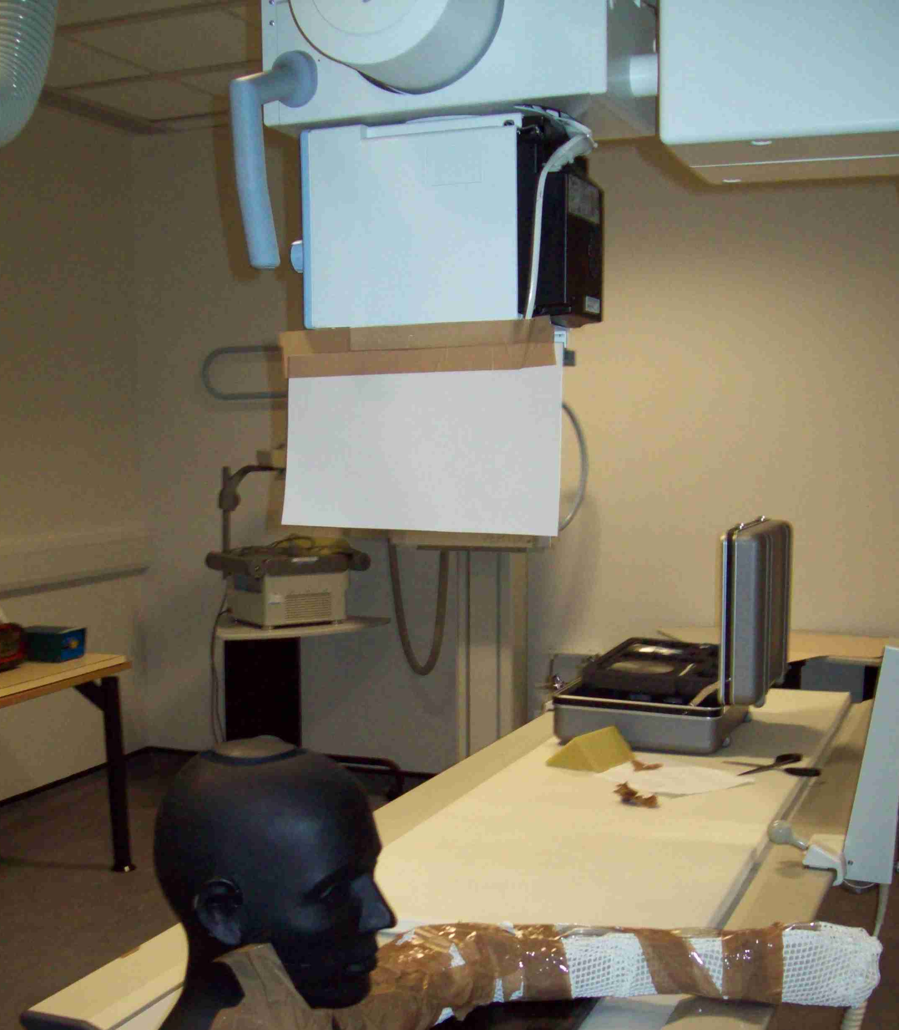  Image 1: Placement of lead-rubber inferolateral to the LBD device and hypothesised to limit ionising radiation to radiosensitive organs. | 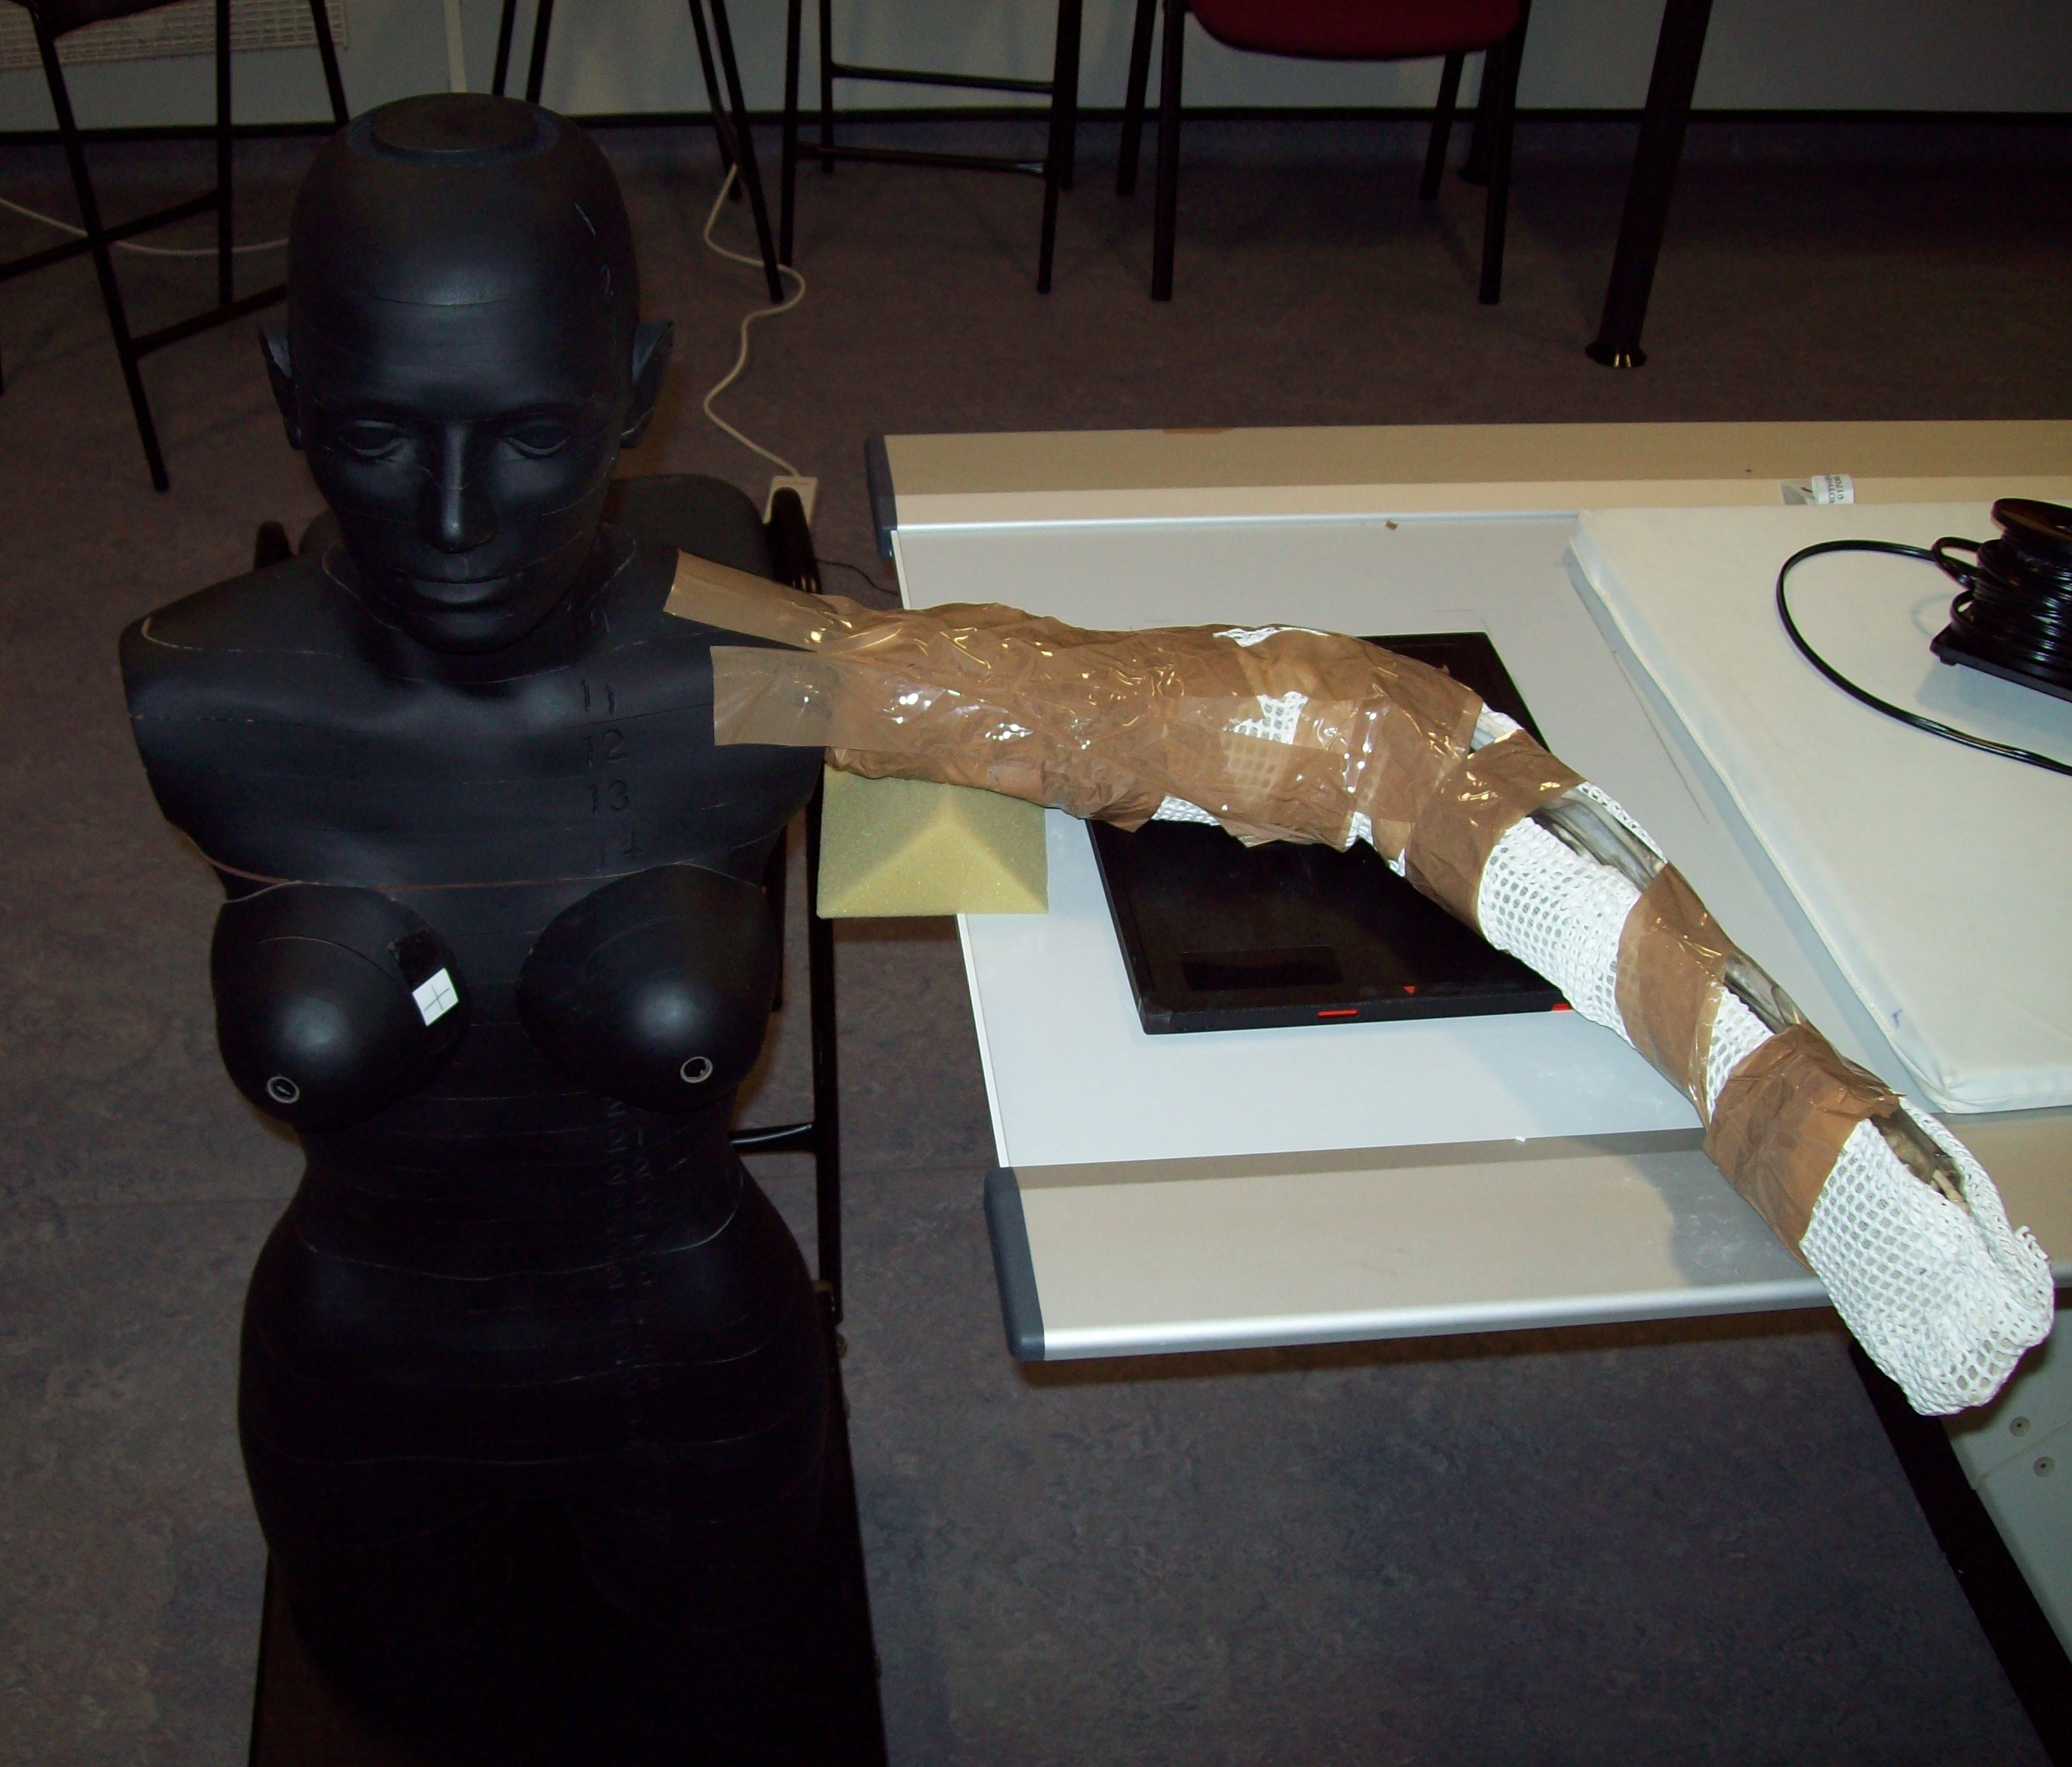  Image 2: Anthropomorphic phantom and positioning representing a patient attending a lateral elbow examination.
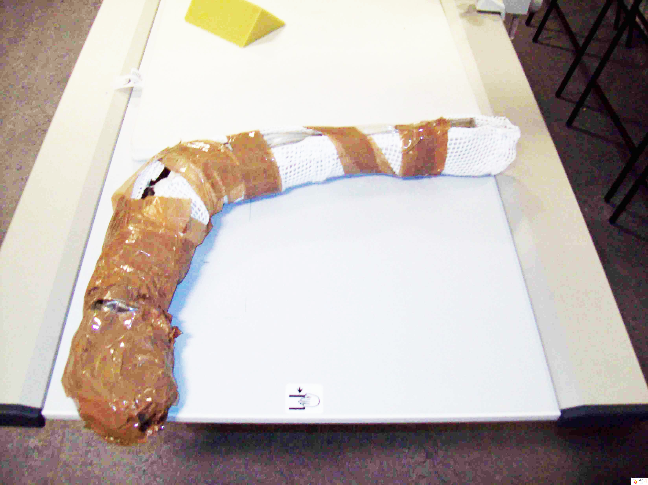  Image 3: Photograph demostrating limb construction. | 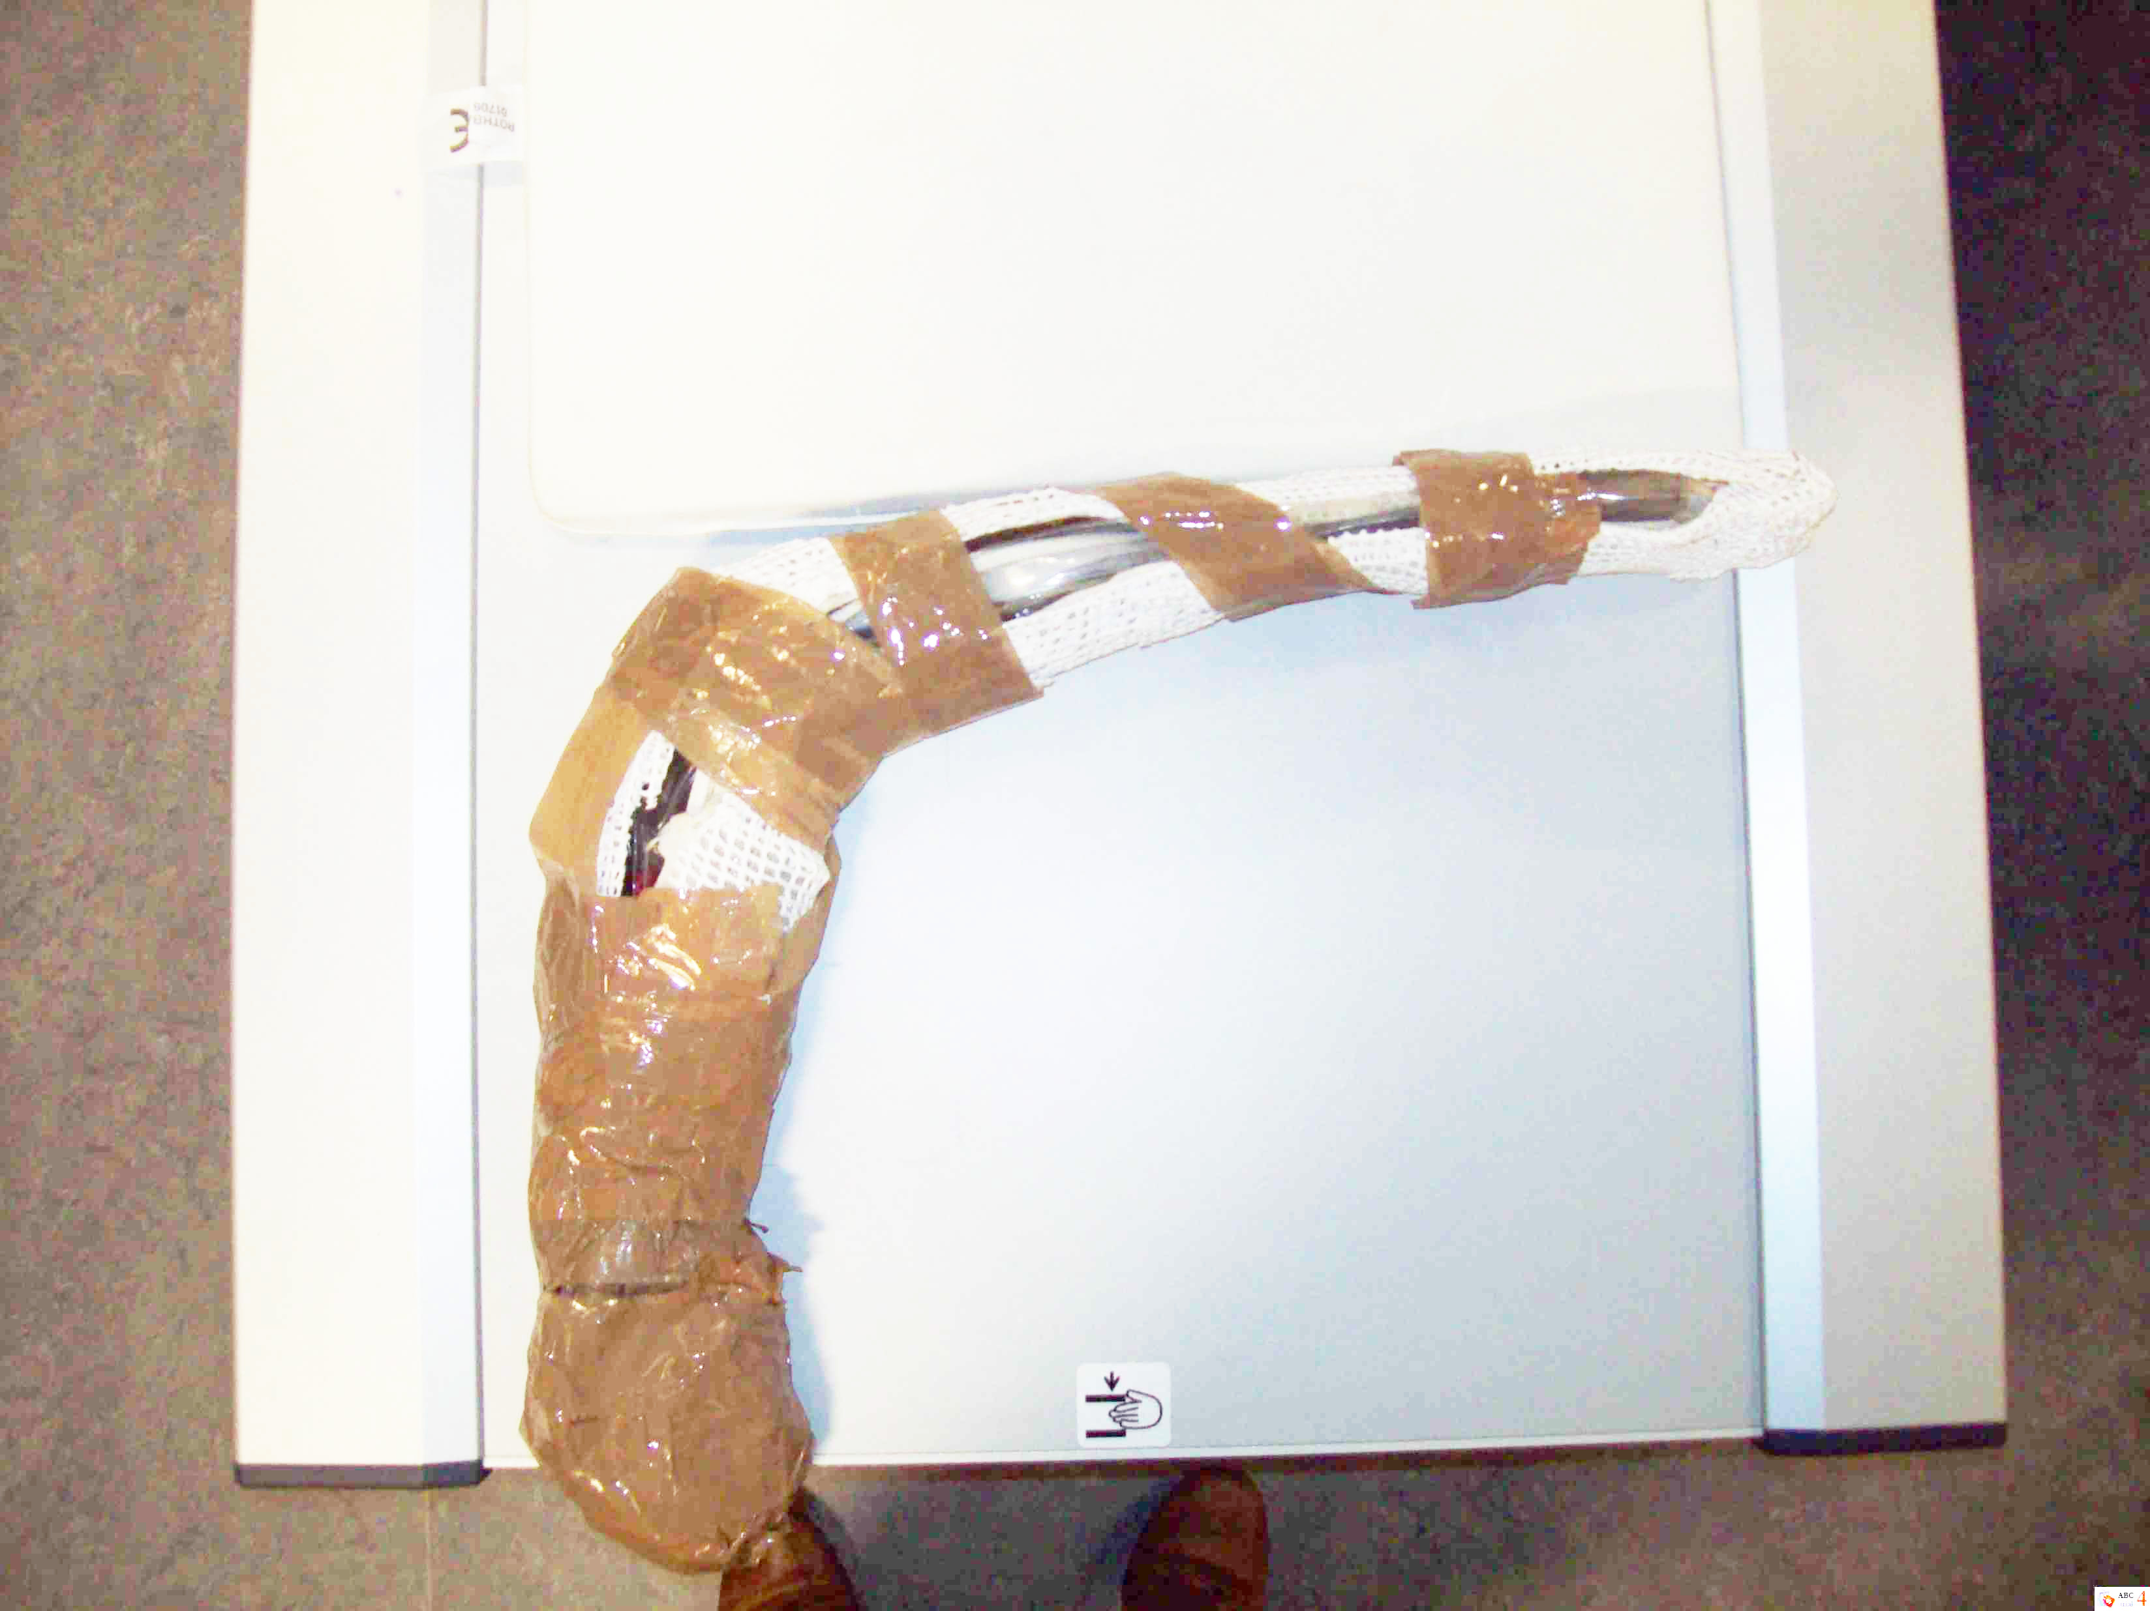  Image 4: Photograph demonstrating limb construction

Radiographic positioning mimicked a female patient attending for a left lateral radiographic examination of the elbow. In accordance with radiography positioning literature the phantom and arm construction were positioned with the patients’ arm and forearm placed in the lateral position with the elbow joint flexed at 90$°$ with the hand rotated externally into the true lateral position.⁹

Radiographic parameters and recording of dose

A 15cc ionisation chamber was used to record exposure rates (µGy/sec) to each radiosensitive organ. The 15cc ionisation chamber (model 10100 AT TRIAD) is a technologically advanced, microprocessor-controlled ionisation chamber and is depicted in figure 2.

Figure 2: The 15cc ionisation chamber (model 10100 AT TRIAD)

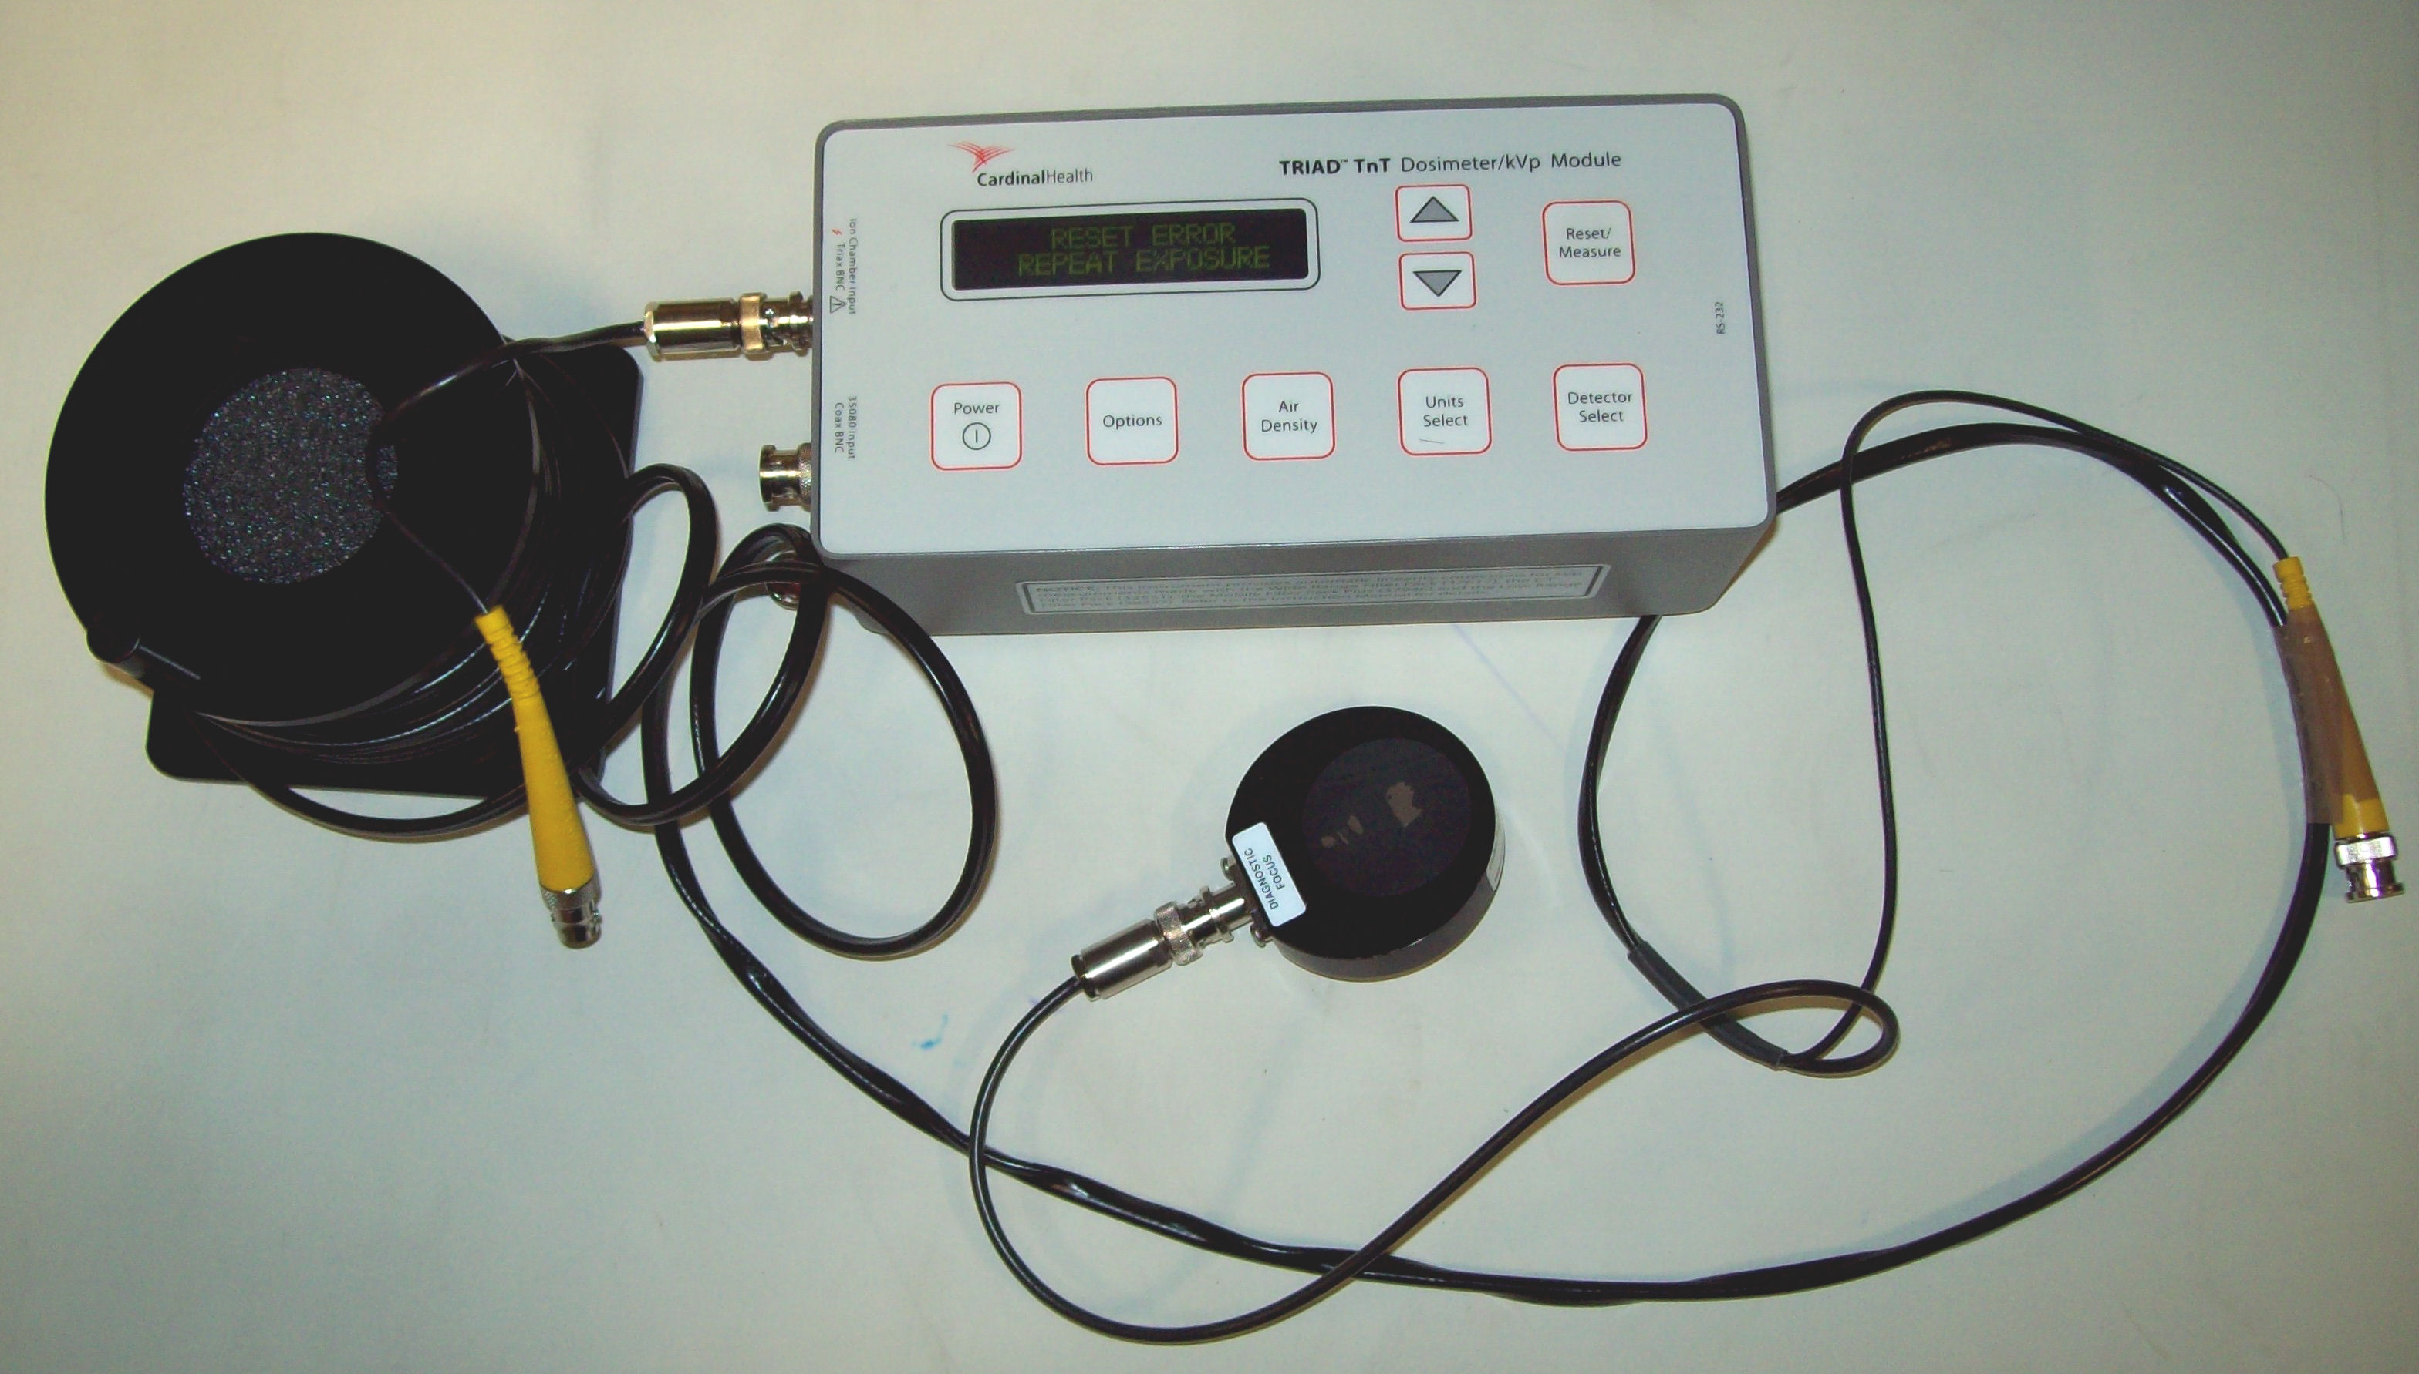

Figure 3 illustrates the placement of the dosimeter for each radiosensitive organ during the experiment, enhancing internal validity. Further, it is important to discuss the accuracy and precision of the ionisation chamber. The exposure accuracy of the device is ± 1% of reading ± 2 range resolution steps over a range of 18° to 28°C and ± 2% of reading ± 2 range resolution steps over the full operating temperature range of 0° to 50°C. Exposure time accuracy is ± 0.1% of reading ± 0.2 msec. Maximum exposure time is 6.5 seconds and measurement resolution is 0.2 msec. Due to the effective range of the ionisation chamber (1-20 µGy/sec), levels of ionising radiation remained undetected using a clinically relevant mAs (3.20 mAs). The inability for the ionization chamber to record exposure rates to radiosensitive organs representative of 3.20 mAs required the author(s) to increase the mAs value (63 mAs, 320 mAs and 560 mAs) to record exposure rates. This will now be discussed.
Upon deciding to increase the mA values this altered the number of electrons flowing across the X-ray tube (with other independent variables remaining unchanged). In short, this altered the intensity of the X-ray beam per unit time thus directly proportional to the mA through the tube. The is represented by equation 1.³

$I ∝mA$ (Equation 1)

Increasing the mA value had a direct relationship on the X-ray quantity and intensity, which allowed the researcher(s) to record an exposure rate from the ionisation chamber. This is important to recognise methodologically because whilst the intensity of the X-ray beam reduces as energy is either absorbed or scattered in matter, a quantifiable reading had been received and thus useful for data collection and analysis. The X-ray spectral intensities for mAs values 63, 360 and 560 are shown in graphs 1, 2 and 3 respectively. These demonstrate that at the maximum keV an increase in mA resulted in a significant increase in both quantity and intensity of the X-ray beam spectra, requiring the application of a regression formula post exposure.

Graph 1: X-ray spectra representative of 63 mAs at 57 kVp

Graph 2: X-ray spectra representative of 360 mAs at 57 kVp

Graph 3: X-ray spectra representative of 560 mAs at 57 kVp

The regression formula applied by the researcher(s) identified the corrected exposure rate. The regression formula is depicted by equation 2.¹⁵ Other independent variables such as kVp, source to image distance (SID), focal spot size, field size and collimation remained constant throughout. Table 1 demonstrates the altered mAs values undertaken by the researcher for each radiosensitive organ.

Figure 3: Placement of the Ionisation Chamber

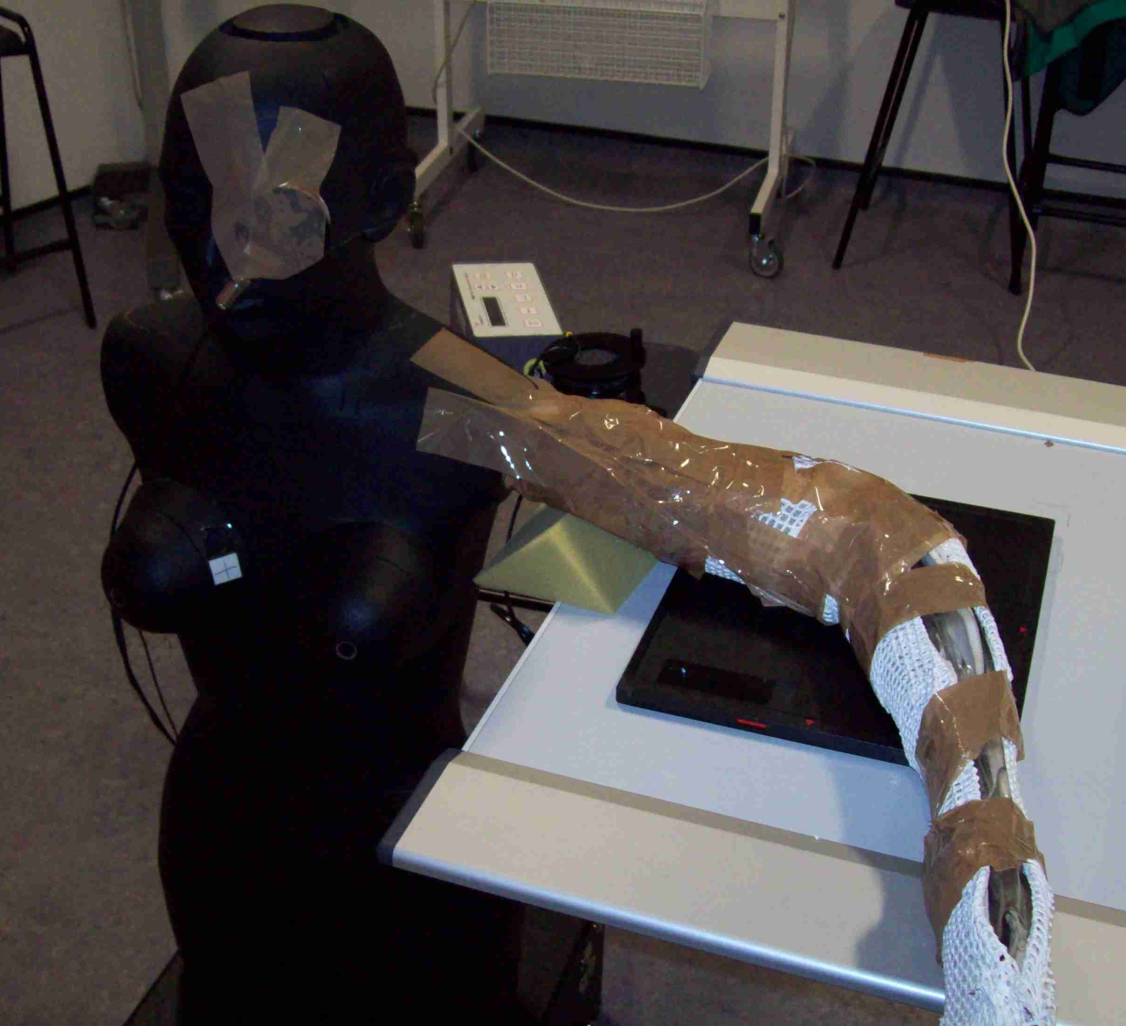 | 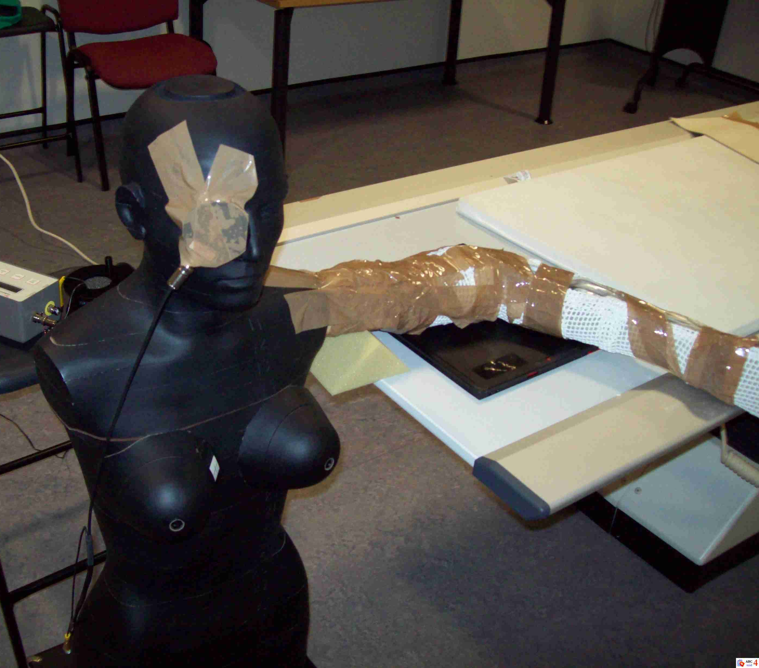 | 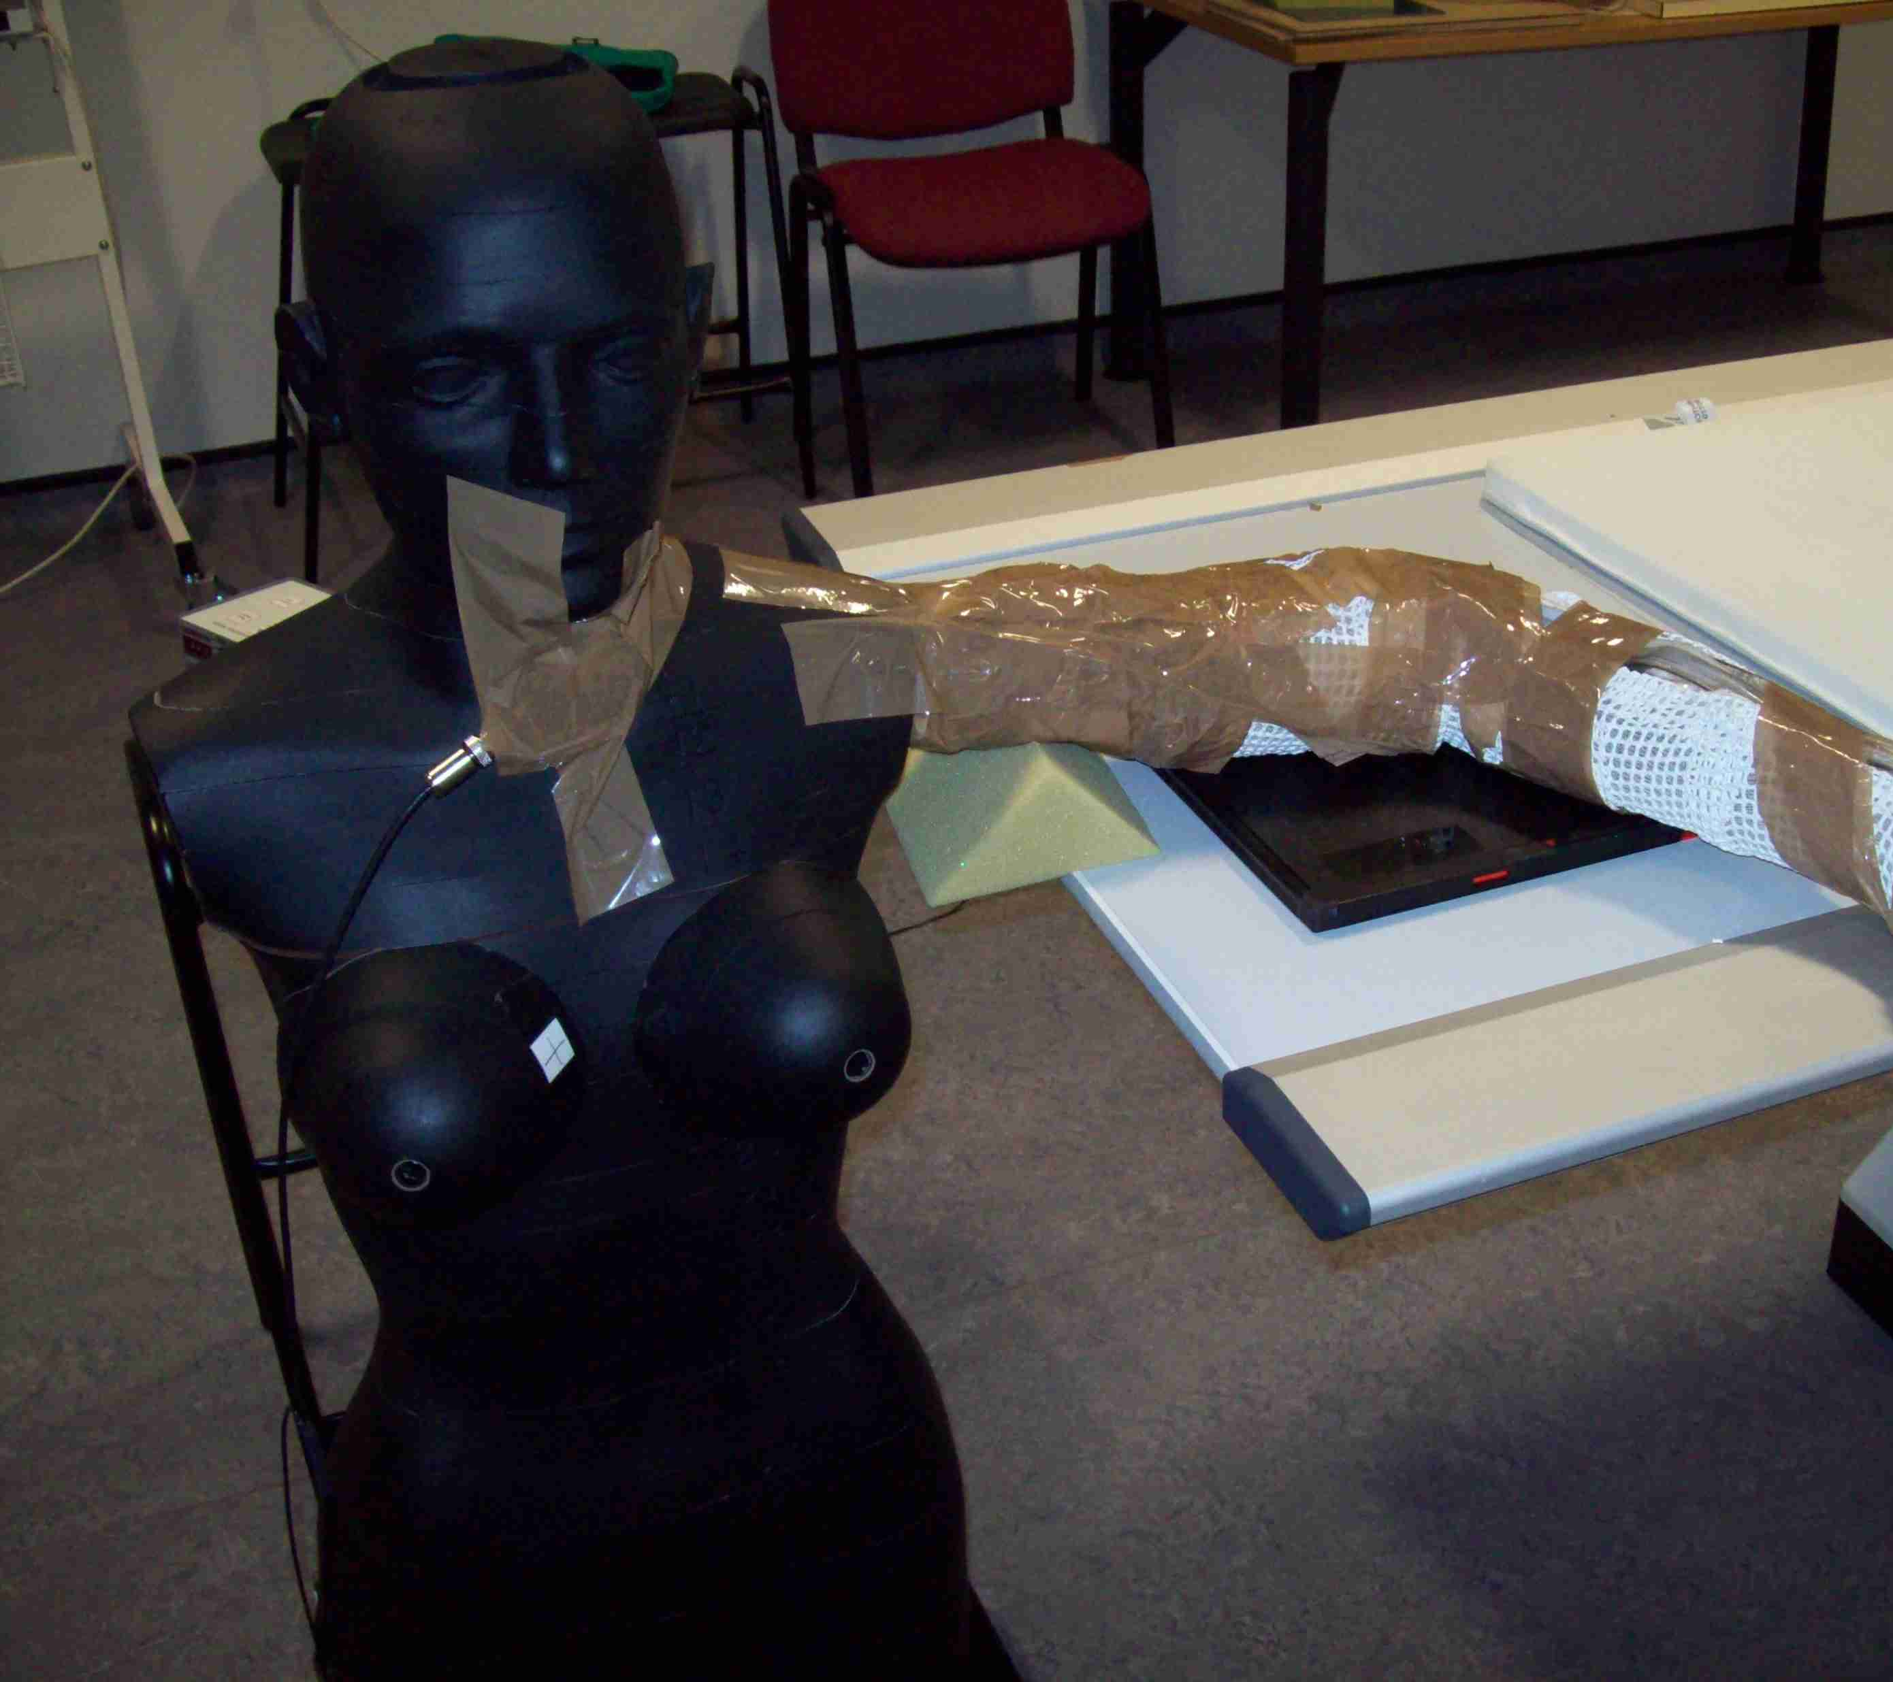
Left Eye | Right Eye | Thyroid
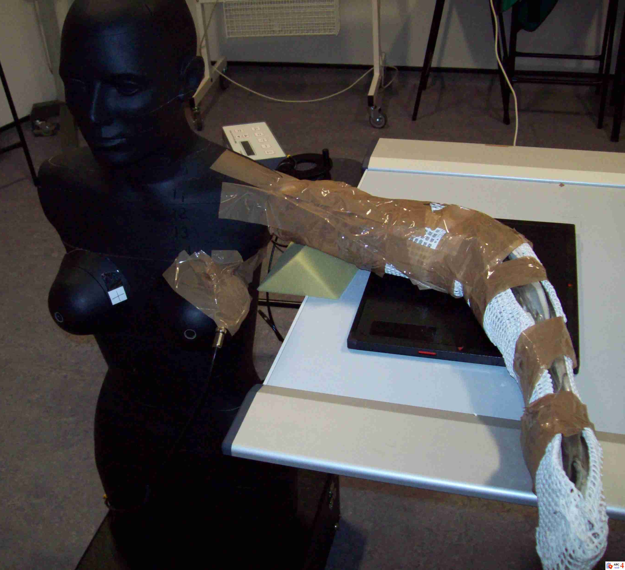 | 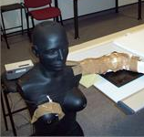 | 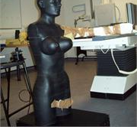
Left Breast | Right Breast | Testes
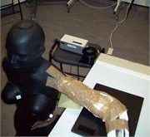 | 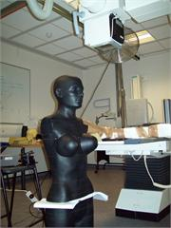
Spleen | Left Ovary | Right Ovary

Upon selection of the lateral elbow examination, three consecutive exposures were made at each point of dosimetry at the location of each radiosensitive organ. Three exposures were undertaken to calculate a mean dose value, enhancing repeatability and precision of the methods employed. This was important to undertake because recording multiple measurements enhanced the precision of dose values and thus decreasing any uncertainty with the ionisation chamber. The observed mean dose value was corrected using the formula depicted in equation 2, which was later used for statistical analysis.

$Corrected mAs=\left(\frac{a}{b}\right)×c$ (Equation 2)

Where $a$ $=$mean of exposure rate (µGy/sec), $b$ $=$set mAs and $c$ $=$clinically relevant mAs (3.20 mAs).

Table 1: Radiographic technique to radiosensitive organs

Exposure (Exp) | Position of  dosimeter | kVp | mAs | SID (cm) | Field Size (cm²) | Focal spot size
Exp. 1 | Left eye | 57 | 63 | 110 | 18 x 18 | Small
Exp. 2 | Right eye | 57 | 63 | 110 | 18 x 18 | Small
Exp. 3 | Thyroid | 57 | 63 | 110 | 18 x 18 | Small
Exp. 4 | Left Breast | 57 | 63 | 110 | 18 x 18 | Small
Exp. 5 | Right Breast | 57 | 63 | 110 | 18 x 18 | Small
Exp. 6 | Spleen | 57 | 63 | 110 | 18 x 18 | Small
Exp. 7 | Testes | 57 | 360 | 110 | 18 x 18 | Small
Exp. 8 | Left Ovary | 57 | 560 | 110 | 18 x 18 | Small
Exp. 9 | Right Ovary | 57 | 560 | 110 | 18 x 18 | Small

A small focal spot size was selected in order to maintain consistency within the controlled experiment. The author(s) decided not to exceed 560 mAs in order to prevent the rotating anode from overheating. Placement of the ionisation chamber in the position of the right ovary did not record any observable readings using 560 mAs thus deemed ‘below dosimeter threshold’. This is represented empirically by the value <0.000 throughout this paper.

Statistical analysis

To ensure the regression formula depicted in equation 2 represented exposure rates representative of a clinically relevant exposure (3.20 mAs), Pearson’s correlation and linear regression analysis were undertaken to support or refute the corrected mean dose values. Statistics demonstrated strong correlation between observed and corrected mean dose values r(8) =.99, p < 0.001. Further, the regression analysis strongly affirmed linearity β=.94, t(8) = 23.10, p < 0.001, thus data extrapolated using the mathematical formula can be used to support discussions and conclusions in this paper.
A paired two sample t-test was undertaken to calculate if dose limitation remained statistically significant. It was used to compare exposure rates ‘before and after’ the implementation of the lead-rubber device. By using the paired sample t-test the findings suggest whether or not the lead-rubber is an appropriate method of dose limitation within the clinical environment.¹⁶ The t-test was undertaken to determine a p – value, indicating how likely the results were attributable to chance. By convention, if there is less than 5% (p < 0.05) chance of the observed differences it is deemed statistically significant.

Results

Exposure rates for each radiosensitive organ are demonstrated in table 2, supported by the mean and corrected mean (µGy). The corrected mean was later used for statistical analysis as this mathematically represented a clinically relevant exposure of 3.20 mAs.

Table 2: Mean exposure rate (µGy/sec) – with and without application of Pb Protection
No lead-rubber attachment inferolateral to LBD device |  |  |  |  |  |  |  | Lead-rubber attachment inferolateral to LBD device
Radiosensitive Organ | µGy1 | µGy2 |  | µGy3 | Mean | Corrected Mean | SD | µGy1 |  |  | µGy2 | µGy3 | Mean | Corrected Mean | SD
Left eye | 7.29 | 7.29 | 7.30 |  | 7.29 | 0.3706 | 0.0058 | 4.45 |  | 4.41 |  | 4.42 | 4.42 | 0.2248 | 0.0208
Right eye | 2.80 | 2.84 | 2.84 |  | 2.82 | 0.1436 | 0.0231 | 1.31 |  | 1.33 |  | 1.31 | 1.32 | 0.0669 | 0.0115
Thyroid | 2.73 | 2.74 | 2.77 |  | 2.74 | 0.1395 | 0.0208 | 2.40 |  | 2.35 |  | 2.40 | 2.38 | 0.1211 | 0.0288
Left Breast | 7.10 | 7.14 | 7.21 |  | 7.15 | 0.3632 | 0.0556 | 6.94 |  | 6.92 |  | 6.87 | 6.91 | 0.3510 | 0.0360
Right Breast | 2.60 | 2.54 | 2.57 |  | 2.57 | 0.1305 | 0.0300 | 1.25 |  | 1.21 |  | 1.19 | 1.22 | 0.0618 | 0.0305
Spleen | 1.09 | 1.11 | 1.11 |  | 1.10 | 0.0560 | 0.0115 | 1.09 |  | 1.05 |  | 1.09 | 1.07 | 0.0547 | 0.0230
Testes | 0.74 | 0.74 | 0.76 |  | 0.74 | 0.0075 | 0.0115 | 0.71 |  | 0.70 |  | 0.69 | 0.70 | 0.0070 | 0.0100
Left Ovary | 0.98 | 0.98 | 0.97 |  | 0.97 | 0.0056 | 0.0057 | 0.88 |  | 0.90 |  | 0.90 | 0.89 | 0.0051 | 0.0115
Right Ovary | <0.000 | <0.000 | <0.000 |  | <0.000 | <0.000 | n/a | <0.000 |  | <0.000 |  | <0.000 | <0.000 | <0.000 | n/a

The corrected mean values of the exposure rates (µGy/sec) to radiosensitive organs are shown in table 3. The values demonstrate mean data with and without the placement of lead-rubber in the inferolateral position to the LBD. The data suggests that dose limitation can be achieved to all radiosensitive organs by placing lead-rubber inferolateral to the LBD device. Importantly, 53% dose limitation is identified to the right breast and right eye lens to patients undergoing a lateral projection of the elbow. Whilst other radiosensitive organs demonstrate minimal dose limitation it remains important in accordance with the LNT dose response model.

Table 3: Dose to radiosensitive organs – with and without Pb protection
Body Part | No Pb protection (corrected mean µGy) |  | Pb protection (corrected mean µGy) | Dose reduction (%)
Left Eye |  | 0.3706 | 0.2248 | 39%
Right Eye |  | 0.1436 | 0.0669 | 53%
Thyroid |  | 0.1395 | 0.1211 | 13%
Left Breast |  | 0.3632 | 0.3510 | 3%
Right Breast |  | 0.1305 | 0.0618 | 53%
Spleen |  | 0.0560 | 0.0547 | 2%
Testes |  | 0.0075 | 0.0070 | 6%
Left Ovary |  | 0.0056 | 0.0051 | 9%
Right Ovary |  | <0.000 | <0.000 | n/a

The data asserts that ionising radiation can be reduced to patients with minimal intervention. Statistical output between the two mean scores along with the standard deviation, degrees of freedom (df) and the value of t is depicted in table 4. The t-test result t = 2.04, df = 7, p = 0.04 is statistically significant and predicts that dose reduction can be achieved upon implementing lead-rubber inferolateral to the LBD.

Table 4: t-test: Paired two sample of mean scores

 | n | Mean | SD | df | t-test | p value
No Pb Protection | 7 | 0.12 | 0.14 | 6 | 2.04 | 0.04
Pb Protection | 7 | 0.09 | 0.11 | 6

Discussion

Reduction of scattered ionising radiation to radiosensitive organs

Consideration of how the exposure parameters affected the X-ray spectrum is important to recognise. The author(s) were required to substantially increase the mAs value to all radiosensitive organs under investigation. Spectral graphs 1, 2, and 3 above demonstrate this, leading to an increase in both quantity and intensity of the X-ray beam (in order to record data). As discussed methodologically, the exposure factors employed were significantly higher than those expected to be used in the clinical environment. However, the use of a regression formula and supporting statistical analysis provides an innovate method of collecting and analysing scattered radiation using an ionising chamber.
The method of dose reduction employed in this study offers practitioners an approach that limits ionising radiation to multiple radiosensitive organs during a single X-ray exposure. In short, the findings demonstrate dose reduction with statistical significance (p = 0.04) by implementing lead-rubber to the inferolateral position of the LBD. An area of significant dose reduction was demonstrated to the left (39%) and right (53%) eye lens of the anthropomorphic phantom. Following a recent review of epidemiological evidence the ICRP recognises the importance of limiting ionising radiation to the lens of the eye following a revised threshold of 0.5 Gy.¹⁷ Whilst this level of exposure is not generally expected in a diagnostic procedures, a primary aim of radiographic practice is limiting stochastic risks where possible. This innovative method facilitates such approaches by keeping doses ALARP. Further, extending the LBD with a high attenuating material could be utilised within interventional environments, whereby high dose levels, such as 0.5 Gy can be expected.
Breast tissue is regarded as the most radiosensitive organ within the human body.¹⁷ Whilst the left breast received the second highest exposure rate of scattered radiation, the implementation of lead-rubber inferolateral to the LBD had little effect (3% dose reduction). On the other hand, the right breast of the anthropomorphic phantom received a significant dose reduction upon the placement of lead-rubber (53%). Whilst these appear dichotomous it provides some insight of the direction of radiation scatter whilst undergoing a lateral projection of the elbow, thus strengthening the rationale for innovative methods of radiation protection. Overall, this method of dose limitation reduced ionising radiation to both breasts thus important to consider within the general radiography environment.
A third significant finding from the data was dose limitation to the thyroid. Radiation dose was reduced by 13% to the thyroid following the application of lead-rubber inferolateral to the LBD. A recent study by Zhang et al¹⁸ suggests that increases in diagnostic radiography procedures are associated with thyroid cancers. Epidemiologic evidence suggests that an array of diagnostic radiography procedures is associated with thyroid carcinomas, warranting further investigation.¹⁸ The findings presented in this paper offer a small but relevant perspective to dose reduction to the thyroid within general radiography and could be incorporated into ‘higher dose’ environments such as interventional fluoroscopic procedures.

Practical implications to clinical practice

An advantage of this dose limiting technique resides in the versatility. For example, the inferolateral placement of lead-rubber to the LBD highlights that it could be applied to numerous patient demographics attending for an elbow examination. For example, it could be applied to traumatic and non-traumatic patients due to the minimal invasiveness imposed onto a patient. A disadvantage of the use of lead-rubber in practice is that it may become problematic during certain procedures. For example, if a radiographer decides to rotate the X-ray tube from a vertical position to a horizontal beam lateral position the lead-rubber may obscure the primary X-ray beam due to its flexibility. This suggests that further consideration to lead protection devices may be required in order to support dose limitation for radiographers in clinical environments.
An important consideration is the suggestion of an inflexible and retractable attachment to the collimation box allowing radiographers ‘the choice’ to ‘pull down’ a high attenuating material that limits scattered ionising radiation to radiosensitive organs. Allowing radiographers an opportunity to ‘expand’ the collimation box during certain radiographic procedures is a logical and realistic conjecture at limiting ionising radiation to patients’ within the clinical environment. In instances whereby the diverging beam is not affected by the material, it could be used clinically to limit unwanted ionising radiation during adult and paediatric examinations thus should be considered in LBD design. Lastly, additional research focusing on other general radiographic projections would promote and uncover the impact of scattered radiation to radiosensitive organs.

Conclusion
A method limiting scattered radiation to radiosensitive organs has been identified. Statistical analysis demonstrated significant dose reduction (p = 0.04) to the radiosensitive organs following the placement of lead-rubber inferolateral to the LBD. This innovative method of lead protection may be useful to radiographers in the clinical environment at limiting ionising radiation to multiple radiosensitive organs during a single X-ray exposure. It is acknowledged that further research and discussion is required to challenge the experimental model undertaken within this study; however it provides a platform for future discussion and possible experimentation.

Recommendations
Further research and discussion is required to challenge LBD design. For example, a retractable high attenuating device placed inferolateral to the LBD could allow radiographers to applying dose reduction strategies to radiosensitive organs depending on the clinical examination/technique employed.

Conflict of interest

None.

References

- Reid-Paul T. Radiologic Technology at a Glance. New York: Delmar; 2011.
- International Atomic Energy Agency. Radiation Protection for Patients. [Online] Available from: https://rpop.iaea.org/RPOP/RPoP/Content/InformationFor/HealthProfessionals/4_InterventionalRadiology/fluoroscopy-operating-theatres/fluoroscopy-patient-protection.htm#FULP-FAQ10 (Accessed: 7th July 2016).
- Graham DT, Cloke P. Principles of Radiological Physics. 4th Edn, London: Churchill Livingstone; 2006.
- Mekis N, Dejan Z, Skrk D. The effect of breast shielding during lumbar spine radiography. Radiology and Oncology. 2013; 47(1):26-31.
- Mekis, N, McEntree, MF, Stegnar, P. PA positioning significantly reduces testicular dose during sacroiliac joint radiography. Radiography. 2010;16:333–338.
- Fung KK, Gilboy WB. The effect of beam tube potential variation on gonad dose to patients during chest radiography investigated using high sensitivity LiF: Mg, Cu, P thermoluminescent dosemeters. British Journal of Radiology. 2001; 74(880): 358-67.
- Guo H, Lui WY, He XY, Zhou XS, Zeng Ql, Li BY. Optimizing image quality and radiation dose by the age-dependent setting of tube voltage in pedatric chest digital radiography. Korean Journal of Radiology. 2013; 14(1):126-131.
- Hamer OW, Volk M, Zorger N, Borisch I, Buttner R, Feuerbach S, Strotzer M. Contrast-detail phantom study for X-ray spectrum optimization regarding chest radiography using a cesium iodide-amorphous silicon flat-panel detector. Investigative Radiology. 2004; 39(10):610-618.
- Whitely CS, Sloane C, Hoadley G, Moore AD, Alsop CW. Clark’s Positioning in Radiography. 12th Edn. London: Hodder Arnold; 2005.
- The Ionising Radiation (Medical Exposure) Regulations. [Online] Available from: https://www.gov.uk/government/publications/the-ionising-radiation-medical-exposure-regulations-2000 (Accessed: 8th July 2016).
- ICRP. The 2007 recommendations of the International Commission on Radiological Protection. ICRP Publication 103; 2007. Ann. ICRP (37) 2-4.
- Williams L, Adams C. Computed tomography of the head: An experimental study to investigate the effectiveness of lead shielding during three scanning protocols. Radiography. 2006; 12(2):143-152.
- Nath R, Yue N, Weinberger J. Dose perturbations by high atomic number materials in intravascular brachytherapy. Cardiovascular Radiation Medicine. 1999; 1(2):144-153.
- Eyden AC. The application of a semiconductor detector in the estimation of the effective dose in radiographic examination of the extremities. PhD Thesis: Canterbury Christ Church University; 2001.
- Long CT. Elementary Introduction to Number Theory. 3rd Edn. Illinois: Waveland Press; 1987.
- Langdridge D, Hagger-Johnson G. Introduction to Research Methods and Data Analysis in Psychology. Harrow: Prentice Hall; 2009.
- ICRP. Statement on tissue reactions and early and late effects of radiation in normal tissues and organs – threshold doses for tissue reactions in a radiation protection context. ICRP Publication 118; 2012. Ann. ICRP (41) 1-2.
- Zhang Y, Chen Y, Huang H, Sandler J, Dai M, Ma S, Udelsman R. Diagnostic radiography exposure increases the risk of thyroid microcarcinoma: a population-based case-conrol study. European Journal of Cancer Prevention. 2015; 24(5):439-436.

